ISO 20022

Settlement and Reconciliation

Message Definition Report - Part 1

Approved by the Securities SEG on 20 January 2022

This document provides information about the use of the messages for Settlement and Reconciliation and includes, for example, business scenarios and messages flows.

February 2022

Table of Contents

Table of Contents 2

1 Introduction 5

1.1 Terms and Definitions 5

1.2 Abbreviations and Acronyms 5

1.3 Document Scope and Objectives 5

1.4 References 6

2 Scope and Functionality 7

2.1 Background 7

2.2 Scope 8

2.3 Groups of MessageDefinitions and Functionality 9

3 BusinessRoles and Participants 12

3.1 Participants and BusinessRoles Definitions 13

3.2 BusinessRoles and Participants Table 13

4 BusinessProcess Description 15

5 Description of BusinessActivities 19

5.1 Instruction and Confirmation - Typical Process 19

5.2 Intra-Position Instruction Process 20

5.3 Partial Settlement Confirmation 22

5.4 Securities Financing Instruction 23

5.5 Pair-off Instruction 32

5.6 Cash/Securities Split Instruction and Confirmation Process 33

5.7 Status Reporting Process 35

5.8 Modification Process 38

5.9 Split Settlement Process 45

5.10 Allegement Process 46

5.11 Reconciliation and Reporting Process 47

5.12 Cancellation Request Process 51

5.13 Cancellation Advise Process 52

5.14 Reversal Advice Process 53

5.15 Portfolio Transfer Process 54

5.16 Transaction Generation Process 55

6 BusinessTransactions 56

6.1 Instruction and Confirmation 56

6.2 Intra-Position Instruction 57

6.3 Partial Settlement Confirmation 57

6.4 Securities Financing 58

6.5 Pair-Off Instruction 69

6.6 Cash/Securities Split Instruction and Confirmation 70

6.7 Status Reporting 71

6.8 Modification 71

6.9 Split Settlement 79

6.10 Allegement 87

6.11 Reconciliation and Reporting 87

6.12 Cancellation Request 90

6.13 Cancellation Advice 91

6.14 Reversal Advice 92

6.15 Portfolio Transfer 92

6.16 Transaction Generation 93

7 Business Examples 94

7.1 SecuritiesBalanceCustodyReport semt.002.001.10 94

7.2 SecuritiesBalanceAccountingReport semt.003.001.10 97

7.3 IntraPositionMovementInstruction semt.013.001.04 102

7.4 IntraPositionMovementStatusAdvice semt.014.001.06 103

7.5 IntraPositionMovementConfirmation semt.015.001.08 104

7.6 IntraPositionMovementPostingReport semt.016.001.08 105

7.7 SecuritiesTransactionPostingReport semt.017.001.10 107

7.8 SecuritiesTransactionPendingReport semt.018.001.11 110

7.9 SecuritiesSettlementTransactionAllegementReport semt.019.001.08 114

7.10 SecuritiesMessageCancellationAdvice semt.020.001.05 117

7.11 SecuritiesStatementQuery semt.021.001.06 117

7.12 SecuritiesSettlementTransactionAuditTrailReport semt.022.001.04 119

7.13 SecuritiesTransactionCancellationRequest sese.020.001.06 120

7.14 SecuritiesTransactionStatusQuery sese.021.001.05 122

7.15 SecuritiesStatusOrStatementQueryStatusAdvice sese.022.001.05 123

7.16 SecuritiesSettlementTransactionInstruction sese.023.001.09 124

7.17 SecuritiesSettlementTransactionStatusAdvice sese.024.001.10 127

7.18 SecuritiesSettlementTransactionConfirmation sese.025.001.09 129

7.19 SecuritiesSettlementTransactionReversalAdvice sese.026.001.08 132

7.20 SecuritiesTransactionCancellationRequestStatusAdvice sese.027.001.05 135

7.21 SecuritiesSettlementTransactionAllegementNotification sese.028.001.08 137

7.22 SecuritiesSettlementAllegementRemovalAdvice sese.029.001.04 139

7.23 SecuritiesSettlementConditionsModificationRequest sese.030.001.08 142

7.24 SecuritiesSettlementConditionsStatusAdvice sese.031.001.08 142

7.25 SecuritiesSettlementTransactionGenerationNotification sese.032.001.09 143

7.26 SecuritiesFinancingInstruction sese.033.001.09 146

7.27 SecuritiesFinancingStatusAdvice sese.034.001.08 148

7.28 SecuritiesFinancingConfirmation sese.035.001.09 150

7.29 SecuritiesFinancingModificationInstruction sese.036.001.07 153

7.30 PortfolioTransferNotification sese.037.001.06 155

7.31 SecuritiesSettlementTransactionModificationRequest sese.038.001.07 162

7.32 SecuritiesSettlementTransactionModificationRequestStatusAdvice sese.039.001.04 163

7.33 SecuritiesSettlementTransactionCounterpartyResponse sese.040.001.02 164

Revision Record 165

Preliminary note:

The Message Definition Report (MDR) is made of three parts:

- MDR - Part 1 describes the contextual background required to understand the functionality of the proposed message set. Part 1 is produced by the submitting organisation that developed or maintained the message set in line with a MDR Part1 template provided by the ISO 20022 Registration Authority (RA) on [www.iso20022.org](http://www.iso20022.org)

- MDR – Part 2 is the detailed description of each message definition of the message set. Part 2 is produced by the RA using the model developed by the submitting organisation.

- MDR – Part 3 is an extract of the ISO 20022 Business Model describing the business concepts used in the message set. Part 3 is an Excel document produced by the RA.

# Introduction

## Terms and Definitions

The following terms are reserved words defined in ISO 20022 Edition 2013 – Part1. When used in this document, the UpperCamelCase notation is followed.

|  |  |
| --- | --- |
| Term | Definition |
| BusinessRole | Functional role played by a business actor in a particular BusinessProcess or BusinessTransaction. |
| Participant | Involvement of a BusinessRole in a BusinessTransaction. |
| BusinessProcess | Definition of the business activities undertaken by BusinessRoles within a BusinessArea whereby each BusinessProcess fulfils one type of business activity and whereby a BusinessProcess may include and extend other BusinessProcesses. |
| BusinessTransaction | Particular solution that meets the communication requirements and the interaction requirements of a particular BusinessProcess and BusinessArea. |
| MessageDefinition | Formal description of the structure of a message instance. |

1. When a MessageDefinition or message identifier is specified, it should include the variant and version number. However, in this document (except in the business examples section, if present), variant and version numbers are not included. In order to know the correct variant and version number for a MessageDefinition, the related Message Definition Report Part 2 document should be consulted.

## Abbreviations and Acronyms

The following is a list of abbreviations and acronyms used in the document.

|  |  |
| --- | --- |
| Abbreviation/Acronyms | Definition |
| ACK | Acknowledgement |
| CA | Corporate Actions |
| CSD | Central Securities Depository |
| ICSD | International Central Securities Depository |
| SMPG | Securities Market Practice Group (www.smpg.info) |

## Document Scope and Objectives

This document is the first part of the Settlement and Reconciliation Message Definition Report (MDR) that describes the BusinessTransactions and underlying message set. For the sake of completeness, the document may also describe BusinessActivities that are not in the scope of the business processes covered in this document.

This document describes the following:

* the BusinessProcess scope
* the BusinessRoles involved in these BusinessProcesses

The main objectives of this document are as follows:

* to provide information about the messages that support the business processes
* to explain the BusinessProcesses and BusinessActivities these messages have addressed
* to give a high level description of BusinessProcesses and the associated BusinessRoles
* to document the BusinessTransactions
* to provide business examples

The messages definitions are specified in Message Definition Report Part 2.

## References

|  |  |  |  |
| --- | --- | --- | --- |
| Document | Version | Date | Author |
| ISO 20022 Business Justification – Securities settlement and reconciliation |  | 2007-09-19 | SWIFT |
| ISO 20022 Settlement and Reconciliation Maintenance Change Request 2016/2017 |  | 2016-09-09 | SWIFT |
| ISO 20022 Settlement and Reconciliation Maintenance Change Request 2017/2018 |  | 2018-02-01 | SWIFT |
| ISO 20022 Settlement and Reconciliation Maintenance Change Request 2018/2019 |  | 2019-02-01 | SWIFT |
| ISO 20022 Settlement and Reconciliation Maintenance Change Request 2019/2020 |  | 2019-12-01 | SWIFT |
| ISO 20022 Settlement and Reconciliation Maintenance Change Request 2020/2021 |  | 2020-12-01 | SWIFT |
| ISO 20022 Settlement and Reconciliation Maintenance Change Request 2020/2021 |  | 2021-12-01 | SWIFT |

# Scope and Functionality

## Background

This Message Definition Report describes a set of 33 ISO 20022 MessageDefinitions developed by SWIFT in close collaboration with the ISO 15022/ISO 20022 community of users. Most of these ISO 20022 message definitions were reverse engineered from ISO 15022 messages.

These messages are specifically designed to support the settlement and reconciliation business processes.

The ISO 15022 and ISO 20022 standards will coexist for a number of years. Until this coexistence period ends, SWIFT will maintain a set of "ISO 15022 variants" of the Settlement and Reconciliation MessageDefinitions, where certain data types are restricted to ensure full interoperability between ISO 15022 and ISO 20022 users. These restrictions have been implemented directly in the message schema of the variants.

This set of messages will be used by intermediaries involved in the settlement and reconciliation processing chain, for example, brokers, investment managers, global custodians, stock exchanges and market infrastructures.

Historical background

With harmonisation industry initiatives such as Giovannini (an EU harmonisation workgroup that was conducted about 10 years ago which identified barriers in post trade services), there is an increasing pressure on the securities industry to go from proprietary standards to ISO standards.

SWIFT was requested by its community to develop ISO 20022 messages equivalent to ISO 15022 to allow ISO 'newcomers' to directly adopt ISO 20022. To limit the impact on existing ISO 15022 users, the ISO 20022 messages were directly reversed engineered from ISO 15022 messages.

In this process, SWIFT made sure to:

* design the ISO 20022 messages with mapping to ISO 15022 in mind to ensure the same levels of STP as today,
* limit the ISO 20022 functionality to the functionality available in ISO 15022 during the coexistence period. That is, it would not be possible to do something with an ISO 20022 message that could not be done in its equivalent ISO 15022 messages and vice versa,
* synchronise the maintenance between the two standards in terms of timing, review process and content,
* provide coexistence support, for example, the necessary mapping or translation documentation.

In addition to the above, SWIFT undertook the following tasks to ensure that the right balance was kept between the need for close reverse engineering from ISO 15022 and the need for leveraging the benefits and principles of ISO 20022:

* ensure that global market practices defined by the Securities Market Practice Group (SMPG) were adhered to during the process,
* solve ISO 15022 standards issues that were identified by the ISO 15022 Registration Authority and the SMPG and that had been postponed awaiting equivalent ISO 20022 messages,
* ensure that additional requirements identified by harmonisation initiatives such as Giovannini were included, in both ISO 15022 and ISO 20022 unless agreed otherwise,
* design the financial instruments identification and attributes based upon the Financial Instrument Business Information Model (FIBIM) as defined by ISO TC 68 SC 4 WG 11.

## Scope

The scope of this set of MessageDefinitions is the reverse engineering of ISO 15022 Settlement & Reconciliation messages (MT 508, 524, 530, 535-8, 540-9, 578, 586) in order to develop equivalent ISO 20022 compliant BusinessTransactions and message set.

As described in the ISO 20022 Business Justification, the scope covers the following communication flows:

Settlement and Confirmation

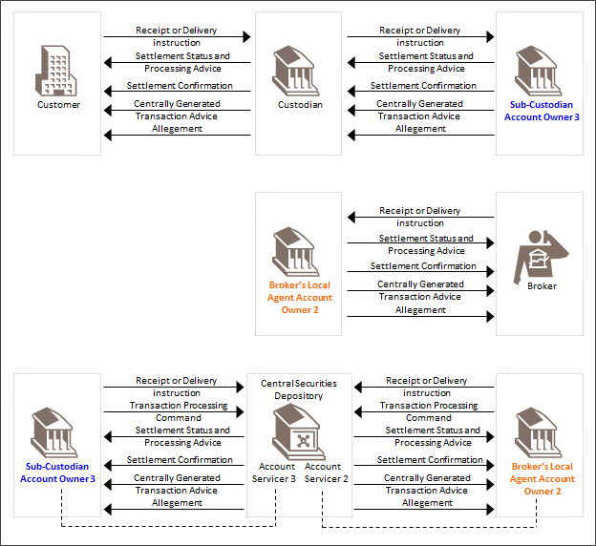

Reporting

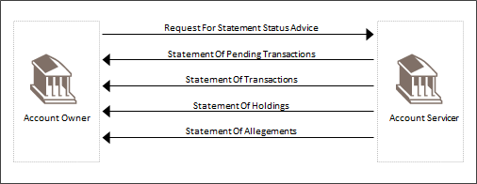

Intra-Position Settlement

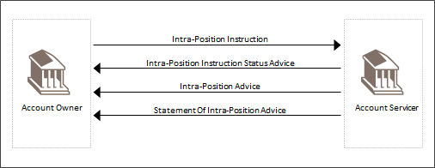

## Groups of MessageDefinitions and Functionality

1. These messages are to be used with the ISO 20022 Business Application Header (head.001). The schema and more information about the Business Application Header (BAH) can be found on the www.iso20022.org web site

### Groups

1. Some messages are part of more than one group since they can be used in the context of more than one business process.

#### Instruction

|  |  |
| --- | --- |
| MessageDefinition | Message Identifier |
| SecuritiesSettlementTransactionInstruction | sese.023 |
| SecuritiesFinancingInstruction | sese.033 |
| IntraPositionMovementInstruction | semt.013 |
| SecuritiesSettlementConditionsModificationRequest | sese.030 |
| SecuritiesFinancingModificationInstruction | sese.036 |

#### Cancellation Request

|  |  |
| --- | --- |
| MessageDefinition | Message Identifier |
| SecuritiesTransactionCancellationRequest | sese.020 |

#### Status Reporting

|  |  |
| --- | --- |
| MessageDefinition | Message Identifier |
| SecuritiesStatementQuery | semt.021 |
| SecuritiesTransactionStatusQuery | sese.021 |
| SecuritiesStatusOrStatementQueryStatusAdvice | sese.022 |
| SecuritiesSettlementTransactionStatusAdvice | sese.024 |
| SecuritiesSettlementConditionModificationStatusAdvice | sese.031 |
| SecuritiesTransactionCancellationRequestStatusAdvice | sese.027 |
| SecuritiesFinancingStatusAdvice | sese.034 |
| IntraPositionMovementStatusAdvice | semt.014 |
| SecuritiesSettlementTransactionGenerationNotification | sese.032 |

#### Confirmation

|  |  |
| --- | --- |
| MessageDefinition | Message Identifier |
| SecuritiesSettlementTransactionConfirmation | sese.025 |
| SecuritiesFinancingConfirmation | sese.035 |
| IntraPositionMovementConfirmation | semt.015 |

#### Reversal

|  |  |
| --- | --- |
| MessageDefinition | Message Identifier |
| SecuritiesSettlementTransactionReversalAdvice | sese.026 |

#### Removal

|  |  |
| --- | --- |
| MessageDefinition | Message Identifier |
| SecuritiesSettlementAllegementRemovalAdvice | sese.029 |

#### Reconciliation

|  |  |
| --- | --- |
| MessageDefinition | Message Identifier |
| SecuritiesStatementQuery | semt.021 |
| SecuritiesTransactionStatusQuery | sese.021 |
| SecuritiesBalanceCustody Report | semt.002 |
| SecuritiesBalanceAccountingReport | semt.003 |
| SecuritiesTransactionPostingReport | semt.017 |
| SecuritiesTransactionPendingReport | semt.018 |
| IntraPositionMovementPostingReport | semt.016 |
| SecuritiesSettlementTransactionAllegementReport | semt.019 |
| SecuritiesSettlementTransactionAuditTrailReport | semt.022 |

#### Allegement

|  |  |
| --- | --- |
| MessageDefinition | Message Identifier |
| SecuritiesSettlementTransactionAllegementNotification | sese.028 |
| PortfolioTransferNotification | sese.037 |
| SecuritiesSettlementTransactionCounterpartyResponse | sese.040 |

#### Modification

|  |  |
| --- | --- |
| MessageDefinition | Message Identifier |
| SecuritiesSettlementTransactionModificationRequest | sese.038 |
| SecuritiesSettlementTransactionModificationRequestStatusAdvice | sese.039 |
| SecuritiesSettlementTransactionCounterpartyResponse | sese.040 |

#### Cancellation Advice

|  |  |
| --- | --- |
| MessageDefinition | Message Identifier |
| SecuritiesMessageCancellationAdvice | semt.020 |

### Functionality

See Message Definition Report Part 2 for the message scopes and formats.

# BusinessRoles and Participants

A BusinessRole represents an entity (or a class of entities) of the real world, physical or legal, a person, a group of persons, a corporation. Examples of BusinessRoles: “Financial Institution”, “Automated Clearing House”, “Central Securities Depository”.

A Participant is a functional role performed by a BusinessRole in a particular BusinessProcess or BusinessTransaction. Examples of Participants: the “user” of a system, “debtor”, “creditor”, “investor”.

The relationship between BusinessRoles and Participants is many-to-many. One BusinessRole can be involved as different Participants at different moments in time or at the same time. Examples of BusinessRoles: "user", "debtor”, "creditor", "investor". Different BusinessRoles can be involved as the same Participant.

In the context of settlement and reconciliation the high-level BusinessRoles and typical Participants can be represented as follows:

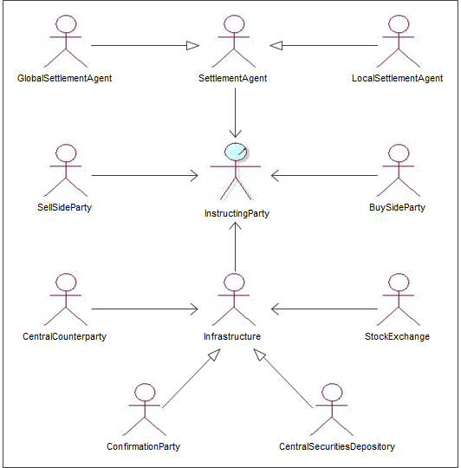

## Participants and BusinessRoles Definitions

Participants

|  |  |
| --- | --- |
| Description | Definition |
| Instructng Party | Party that instructs the executing/servicing party to process and monitor a transaction. The party must own the account or have a power of attorney on the account. |
| Executing/Servicing Party | Party that manages |

Business Roles

|  |  |
| --- | --- |
| Description | Definition |
| Global Settlement Agent | Party that holds another party's inventory of financial instruments, and effects or receives deliveries versus payment, or free of payment. Deliveries, receipts, and payments may be affected within the facilities of the global settlement agent, or within the facilities of a local settlement agent, and directed by the global settlement agent. A global settlement agent may be a custodian and/or a clearing broker. |
| Local Settlement Agent | Party that holds a portion of another party's inventory of financial instruments within a location or market, effects or receives local deliveries versus payment, or free of payment, as directed by the global settlement agent. A local settlement agent may be a local custodian and/or a local clearing broker. |
| Sell Side Party | Broker that sells its services (for example, research, analysis and recommendation), to buy-side parties. |
| Buy Side Party | Individual or institution, that purchases or sells financial instruments, for its own account, or on behalf of an investor. |
| Central Counterparty | Infrastructure that is very often a component of a clearinghouse, and facilitates clearing and settlement for its members by standing between the buyer and the seller of a trade. It may net transactions, and substitutes itself as settlement counterparty to each position. |
| Stock Exchange | Market in which securities, commodities, options or futures are traded. |
| Confirmation Party | An infrastructure that issues trade confirmations, receives trade affirmations, matches allocations to confirmations and confirmations to instructions, and generates standing or special instructions to create settlement instructions. |
| CSD / ICSD | Infrastructure that, holds or controls, the holding of physical or dematerialised financial instruments belonging to all, or a large portion of, the investors in a securities market. It effects the centralised transfer of ownership of such securities by entries on its books and records. The depository may delegate custody to another entity (custodian). |
| Settlement Infrastructure | Party that provides services to its members for the settlement of transactions and holding of assets, for example, T2S. |

## BusinessRoles and Participants Table

|  |  |  |
| --- | --- | --- |
| BusinessRole | Participant  Account Servicer | Participant  Account Owner |
| Global Settlement Agent | x | x |
| Local Settlement Agent | x | x |
| Sell Side Party | x |  |
| Buy Side Party | x |  |
| Central Counterparty | x |  |
| Stock Exchange | x |  |
| Confirmation Party | x |  |
| CSD | x | x |
| Settlement Infrastructure |  | x |

# BusinessProcess Description

This diagram represents the high level BusinessProcesses.



Instruction

|  |  |
| --- | --- |
| Item | Description |
| Definition | The process of instructing the settlement, booking, movement of securities (a settlement transaction). This process includes all non-corporate acton transactions having an impact on a safekeeping account aggregate or sub-balance: intra-position movement, plain vanilla settlement instructions, account transfers, securities financing settlement, physical deliveries, etc. |
| Trigger | The process is triggered by an external process, such as an exchange or OTC trade, a realignment process, a Repo trade, a portfolio transfer, etc. |
| Pre-conditions | None. |
| Post-conditions | The acknowledgement of the acceptance of the instruction. |
| Role | Instructing party. |

Modification

|  |  |
| --- | --- |
| Item | Description |
| Definition | The process of modifying an open transaction to change a processing attribute of the transaction or amend an incorrect transaction data. |
| Trigger | Depending on market practices or SLA, the process is triggered by a status report leading to the need to modify, or by an external process. |
| Pre-conditions | A settlement transaction must be in place. It must be possible to modify. |
| Post-conditions | The acknowledgement of the processing of the modification request. |
| Role | Instructing party. |

Cancellation Request

|  |  |
| --- | --- |
| Item | Description |
| Definition | The process of requesting the cancellation of an open transaction. |
| Trigger | The process is triggered by the need to cancel outright an open transaction, or as the first step of the modification process in markets where amending transaction data is not allowed. |
| Pre-conditions | An open transaction must be in place. It must be possible to cancel. |
| Post-conditions | The acknowledgement of the processing of the cancellation request. |
| Role | Instructing party. |

Status Reporting

|  |  |
| --- | --- |
| Item | Description |
| Definition | The process of providing or relaying the status of a transaction during the various phases of its lifecycle. |
| Trigger | The process is triggered by the execution of the various steps of the lifecycle of a transaction on the market. This lifecycle may differ from transactions to transactions. |
| Pre-conditions | An open transaction must be in place. |
| Post-conditions | The transaction is closed. |
| Role | Executing/servicing party. |

Confirmation

|  |  |
| --- | --- |
| Item | Description |
| Definition | The process of informing about the end of the lifecycle of a transaction following the account movement that it has triggered. |
| Trigger | The process is triggered by the execution of the last step of the lifecycle of a transaction on the market and the corresponding movement in the impacted safekeeping account (aggregate balance or sub-balance). |
| Pre-conditions | A settled transaction must be in place. It must be ready for confirmation. |
| Post-conditions | None. |
| Role | Executing/servicing party. |

Reversal

|  |  |
| --- | --- |
| Item | Description |
| Definition | The process of reversing a confirmed transaction, that is, to put it back to an open status. |
| Trigger | The process is triggered by the need to reverse a transaction that should not have been confirmed or for which the receiving party has returned the shares. |
| Pre-conditions | The transaction must have been confirmed. Reversal must be possible. |
| Post-conditions | The underlying settlement instruction will still be in the settlement process. The account owner will receive statuses and confirmation advices. |
| Role | Executing/servicing party. |

Allegement

|  |  |
| --- | --- |
| Item | Description |
| Definition | The process of informing an instructing party about a counterparty pending transaction for which no instruction has been received. |
| Trigger | The process is triggered by the identification of a pending counterparty transaction and the identification of the party that should initiate an instruction processing to match the pending counterparty transaction. |
| Pre-conditions | An open counterparty transaction must be in place. |
| Post-conditions | The instructing party has instructed a matching transaction or a counterparty cancelled its transaction. |
| Role | Executing/servicing party. |

Removal

|  |  |
| --- | --- |
| Item | Description |
| Definition | The process of removing an allegement that is no longer pending following the sending of a matching instruction by the alleged party. |
| Trigger | The process is triggered by the processing of a matching instruction. |
| Pre-conditions | An allegement must have been sent. |
| Post-conditions | None. |
| Role | Executing/servicing party. |

Cancellation Advice

|  |  |
| --- | --- |
| Item | Description |
| Definition | The process of advising about the cancellation of an executing/servicing party communication. |
| Trigger | The process is triggered by a previous communication being identified as inaccurate or void. |
| Pre-conditions | A previous communication must have taken place. |
| Post-conditions | None. |
| Role | Executing/servicing party. |

Reconciliation

|  |  |
| --- | --- |
| Item | Description |
| Definition | The process of enabling the reconciliation of holdings (accounting and custody), of (pending) transactions, of allegements... through the providing of the necessary data. |
| Trigger | The process is triggered by the account set-up of an account owner and its requirements in terms of reporting, or by the receipt of a request for statement. |
| Pre-conditions | None. |
| Post-conditions | None. |
| Role | Executing/servicing party. |

# Description of BusinessActivities

This section presents the different BusinessActivities within each BusinessProcess. The BusinessActivities of a process are described with activity diagrams.

Legend

|  |  |  |
| --- | --- | --- |
| Symbol | Name | Definition |
|  | Start Point | Shows where the lifecycle of the business process commences. |
|  | End Point | Shows where the lifecycle of the business process may ends. |
|  | Lozenge (or diamond) | Indicates that a choice between several actions can be made. |
|  | Bar | Indicates that several actions are initiated in parallel. |

## Instruction and Confirmation - Typical Process

Applies to plain vanilla settlement, account transfers and intra-position movement instructions.



|  |  |  |
| --- | --- | --- |
| Step | Description | Initiator |
| Instruct | Instruct a debit or credit of securities against or free of payment, based on an instruction received by a client or not. | Instructing Party |
| Process Instruction | Technical and business validation of the details of the instruction before further processing or not. | Executing/Servicing Party |
| Processed Yes/No | If YES, that is, the instruction is ready for further processing, the next step is the matching and settlement activity. It is understood that, though not shown on the diagram, a status update may also occur following a YES.  If NO, the update status activity is done. | Executing/Servicing Party |
| Monitor Matching and Settlement process | The aim of the diagram is to describe the settlement instruction and confirmation process. This activity is therefore summarised in one box. | Instructing Party |
| Matching and settlement process | The aim of the diagram is to describe the settlement instruction and confirmation process. This activity is therefore summarised in one box. | Executing/Servicing Party |
| Settled No/Yes | If NO, go to update status activity. If YES, go to settle trade activity. | Instructing Party |
| Settled No/Yes | If NO, go to update status activity. If YES, go to settle trade activity. | Executing/Servicing Party |
| Update status | Update status. | Instructing Party |
| Update status | Update status (and inform about it). | Executing/Servicing Party |
| Settle instruction | Settle the instruction in the system. | Instructing Party |
| Settle instruction | Settle the instruction in the system. | Executing/Servicing Party |

## Intra-Position Instruction Process



|  |  |  |
| --- | --- | --- |
| Step | Description | Initiator |
| Instruct intra-position movement | Instruct a movement from one sub-balance to another or from one balance status to another based on a request received by a client or not. | Instructing Party |
| Process instruction | Technical and business validation of the details of the request before further processing or not. | Executing/Servicing Party |
| Processed Yes/No | If YES, that is, the instruction is ready for further processing, the next step is the intra-position movement process.  If NO, the update status activity is done. | Executing/Servicing Party |
| Monitor intra-position movement instruction | Monitor the status of the instruction | Instructing Party |
| Intra-position movement process | Attempt the movement from one sub-balance to another or from one balance status to another. It may lead to an instruction being sent further down the chain. | Executing/Servicing Party |
| Executed No/Yes | If NO, go to update status activity. If YES, go to move position activity. | Instructing Party |
| Executed No/Yes | If NO, go to update status activity. If YES, go to move position activity. | Executing/Servicing Party |
| Update Status | Update status (and inform about it). | Instructing Party |
| Update Status | Update status (and inform about it). | Executing/Servicing Party |
| Move position | Move the holding from one sub-balance to another or from one balance status to another. | Instructing Party |
| Move position | Move the holding from one sub-balance to another or from one balance status to another (and advice about it). | Executing/Servicing Party |

## Partial Settlement Confirmation



|  |  |  |
| --- | --- | --- |
| Step | Description | Initiator |
| Instruct settlement | Instruction of the settlement, based on an instruction received by a client or not. | Instructing Party |
| Process instruction | Technical and business validation of the details of the instruction before further processing or not. | Executing/Servicing Party |
| Processed Yes/No | If YES, that is, the instruction is ready for further processing, the next step is the matching and settlement activity. It is understood that, though not shown on the diagram, a status update may also occur following a YES.  If NO, the update status activity is done | Executing/Servicing Party |
| Monitor matching and settlement process | The aim of the diagram is to describe the settlement instruction and confirmation process. This activity is therefore summarised in one box. | Instructing Party |
| Monitor matching and settlement process | The aim of the diagram is to describe the settlement instruction and confirmation process. This activity is therefore summarised in one box. | Executing/Servicing Party |
| Settled No/Yes | If NO, go to update status activity. If YES, go to settle trade activity. | Instructing Party |
| Settled No/Yes | If NO, go to update status activity. If YES, go to settle trade activity. | Executing/Servicing Party |
| Update status | Update status (and inform about it). | Instructing Party |
| Update status | Update status (and inform about it). | Executing/Servicing Party |
| Partially settled Yes/No | If NO, got to settle instruction. If YES, got to partially settle. | Instructing Party |
| Partially settled Yes/No | if NO, got to settle instruction. If YES, got to partially settle. | Executing/Servicing Party |
| Settle instruction | Settle the instruction in the system. | Instructing Party |
| Settle instruction | Settle the instruction in the system and inform about it. | Executing/Servicing Party |
| Partially settle | Partially settle the instruction and go back to matching/settlement process with the remaining quantity to be settled. | Instructing Party |
| Partially settle | Partially settle the instruction (and inform about it) and go back to matching/settlement process with the remaining quantity to be settled. | Executing/Servicing Party |

## Securities Financing Instruction

During the reverse engineering project, it was agreed that securities financing services should be handled using specific securities financing messages. It will ensure the settlement instruction and confirmation messages are as simple and dedicated as possible.

Settlement instructions and confirmation messages are therefore no longer to be used to advise an account servicer about the terms of a Repo, or to modify such terms. This is done using the dedicated message set developed for securities financing transaction management.

The pure settlement of the opening and closing leg, when no securities financing information is required, can still be handled using regular settlement messages instruction and confirmation

The above applies to repo/reverse repo, securities lending and securities borrowing (managed by a Securities Financing Servicing Party).

### Securities Financing Instruction and Confirmation

#### Three Parties



|  |  |  |
| --- | --- | --- |
| Step | Description | Initiator |
| Instruct securities financing transaction | Instruction of repo, reverse repo, securities lending settlement and securities borrowing settlement, based on an instruction received by a client or not. | Securities Financing Instructing Party |
| Process instruction | Technical and business validation of the details of the instruction before further processing or not. | Securities Financing Servicing Party |
| Processed Yes/No | If YES, that is, the instruction is ready for further processing, the next step is the instruct settlement and monitor activity. It is understood that, though not shown on the diagram, a status update may also occur following a YES.  If NO, the update status activity is done. | Securities Financing Servicing Party |
| Process instruction | Technical and business validation of the details of the two instructions (closing and opening) before further processing or not. | Settlement Executing Party |
| Instruct settlement and monitor | Instruction of the opening and closing leg for settlement in a scenario where the next party in the chain will only execute the settlement of the opening and closing legs. | Securities Financing Servicing Party |
| Processed Yes/No | If YES, that is, the instructions are ready for further processing, the next step is the matching and settlement activity. It is understood that, though not shown on the diagram, a status update may also occur following a YES.  If NO, the update status activity is done. | Settlement Executing Party |
| Monitor securities financing transaction | Monitor the transaction and report to client based on status and confirmations received from the securities financing servicing party. | Securities financing Instructing Party |
| Monitor securities financing transaction | Monitor the transaction and report to client based on status and confirmations received from the settlement executing party. | Securities Financing Servicing Party |
| Matching and settlement process | The aim of the diagram is to describe the instruction and confirmation process. This activity is therefore summarised in one box. | Settlement Executing Party |
| Opening settled No/Yes | If NO, go to update status activity. If YES, go to settle opening activity. | Securities financing Instructing Party |
| Opening settled No/yes | If NO, go to update status activity. If YES, go to settle opening activity. | Securities Financing Servicing Party |
| Settled No/Yes | If NO, go to update status activity. If YES, go to settle instruction(s) activity. | Settlement Executing Party |
| Closing settled No/Yes | If NO, go to update status activity. If YES, go to settle closing activity | Securities financing Instructing Party |
| Closing settled No/yes | If NO, go to update status activity. If YES, go to settle closing activity. | Securities Financing Servicing Party |
| Update status | Update status (and inform about it). | Settlement Executing Party |
| Update status | Update status (and inform about it) | Securities financing Instructing Party |
| Update status | Update status and inform the instructing party about it. | Securities Financing Servicing Party |
| Settle instruction | Settle the instruction(s) in the system. | Settlement Executing Party |
| Settle opening | Settle the opening leg of the transaction | Securities financing Instructing Party |
| Settle opening | Settle the opening leg of the transaction and advise the instructing party. | Securities Financing Servicing Party |
| Settle closing | Settle the closing leg of the transaction. | Securities financing Instructing Party |
| Settle closing | Settle the closing leg of the transaction and advise the instructing party. | Securities Financing Servicing Party |

1. If it is a Repo with multiple pieces of collateral, there should be one securities financing instruction per piece of collateral as today.

#### Two Parties (Securities Financing Servicing Party and the Settlement Executing Party are the Same)



|  |  |  |
| --- | --- | --- |
| Step | Description | Initiator |
| Instruct securities financing transaction | Instruction of repo, reverse repo, securities lending settlement and securities borrowing settlement transactions, based on an instruction received by a client or not. | Securities Financing Instruction Party |
| Process instruction | Technical and business validation of the details of the instruction before further processing or not. | Securities Financing Servicing Party/Settlement Executing Party |
| Processed Yes/No | If YES, that is, the instruction is ready for further processing, the next step is the instruct settlement and monitor activity. It is understood that, though not shown on the diagram, a status update may also occur following a YES. | Securities Financing Servicing Party/Settlement Executing Party |
| Create securities financing transactions settlement and monitor | Instruction of the opening and closing leg for settlement in a scenario where the next party in the chain will only execute the settlement of the opening and closing legs. | Securities Financing Servicing Party/Settlement Executing Party |
| Process instruction | Opening and closing and opening. | Securities Financing Servicing Party/Settlement Executing Party |
| Manage securities financing transaction | Monitor the transaction and report to client based on status and confirmations received from the securities financing servicing party. | Securities Financing Instruction Party |
| Manage securities financing transactions | Monitor the transaction and report to client based on status and confirmations received from the settlement executing party. | Securities Financing Servicing Party/Settlement Executing Party |
| Opening settled No/Yes | If NO, go to update status activity. If YES, go to settle opening activity. | Securities Financing Instruction Party |
| Opening settled No/Yes | If NO, go to update status activity. If YES, go to settle opening activity. | Securities Financing Servicing Party/Settlement Executing Party |
| Closing settled No/yes | If NO, go to update status activity. If YES, go to settle closing activity. | Securities Financing Instruction Party |
| Closing settled No/yes | If NO, go to update status activity. If YES, go to settle closing activity. | Securities Financing Servicing Party/Settlement Executing Party |
| Update status | Update status (and inform about it). | Securities Financing Instruction Party |
| Update status | Update status and inform the instructing party about it. | Securities Financing Servicing Party/Settlement Executing Party |
| Settle opening | Settle the opening leg of the transaction. | Securities Financing Instruction Party |
| Settle opening | Settle the opening leg of the transaction and advice the instructing party. | Securities Financing Servicing Party/Settlement Executing Party |
| Settle closing | Settle the closing leg of the transaction. | Securities Financing Instruction Party |
| Settle closing | Settle the closing leg of the transaction and advice the instructing party. | Securities Financing Servicing Party/Settlement Executing Party |

### Modification Process

Several types of modification of securities financing transaction may occur. For activity diagram illustration purposes, the types of modification are regarded as two categories:

* Changes that do not impact the securities position
* Changes impacting the securities position

For all changes, it is assumed that the opening leg has been settled and that it is still possible to modify the closing leg details.

Important Notes

* If the opening leg is pending and the change impacts the closing leg, SecuritiesFinancingModificationInstruction is sent.
* If the opening leg is pending and the change impacts the opening leg, a cancel and a new message will be sent out.
* If the opening leg is settled but not the closing and a change impacts the closing leg, SecuritiesFinancingModificationInstruction will be sent
* If the opening leg is settled and a change is sent for the opening leg. Nothing can be done except request an earlier termination of the closing leg.
* These above will be clearly stated in the Securities Financing High Level model.

#### Changes That Do Not Impact the Securities Position

This model applies to rate, date, amount, price closing leg changes not impacting the securities position, for example, repo call, repo rollover, repo rate change and securities lending return date change.

Three Parties



|  |  |  |
| --- | --- | --- |
| Step | Description | Initiator |
| Request modification | Request the modification a securities financing transaction detail. | Securities Financing Instructing Party |
| Process modification | Technical and business validation of the details of the instruction before further processing or not. | Securities Financing Servicing Party |
| Processed Yes/No | If YES, that is, it is possible to process the modification, the next step is Replace closing leg. It is understood that, though not shown on the diagram, a status update may also occur following a YES.  If NO, the update status activity is done. | Securities Financing Servicing Party |
| Process instruction | Technical and business validation of the details of the modification request before further processing. | Settlement Executing Party |
| Monitor modification request | Monitor the processing of the modification request. | Securities Financing Instructing Party |
| Update status | Update processing status and inform about it. | Securities Financing Servicing Party |
| Processed Yes/No | If YES, that is, the instructions are ready for further processing, the next step is the matching and settlement activity. It is understood that, though not shown on the diagram, a status update may also occur following a YES.  If NO, the update status activity is done. | Settlement Executing Party |
| Modified Yes/No | If YES, Modify securities financing transaction.  If NO, modification process ends. | Securities Financing Instructing Party |
| Replace closing leg | Instruct the settlement executing party to replace the closing leg. If the settlement executing party is the securities financing servicing party, or if the closing leg is not yet instructed, this may lead to an internal process only. | Securities Financing Servicing Party |
| Matching and settlement process | The aim of the diagram is to describe the instruction and confirmation process. This activity is therefore summarised in one box. | Settlement Executing Party |
| Modify securities financing transaction | Following confirmation the modification request took place; modify internally the details of the securities financing transaction. | Securities Financing Instructing Party |
| Update status | Following the modification of the opening (and if applicable of the closing leg), report status on the securities financing transaction. | Securities Financing Servicing Party |
| Update status | Update status (and inform about it). | Settlement Executing Party |

Two Parties



|  |  |  |
| --- | --- | --- |
| Step | Description | Initiator |
| Request modification | Request the modification a securities financing transaction detail | Securities Financing Instructing Party |
| Process modification | Technical and business validation of the details of the instruction before further processing or not. | Securities Financing Servicing Party/Settlement Executing Party |
| Processed Yes/No | If YES, that is, it is possible to process the modification, the next step is Replace closing leg. It is understood that, though not shown on the diagram, a status update may also occur following a YES.  If NO, the update status activity is done. | Securities Financing Servicing Party/Settlement Executing Party |
| Monitor modification request | Monitor the processing of the modification request. | Securities Financing Instructing Party |
| Update status | Update processing status and inform about it. | Securities Financing Servicing Party/Settlement Executing Party |
| Modified Yes/No | If YES, Modify securities financing transaction.  If NO, modification process ends. | Securities Financing Instructing Party |
| Replace closing leg | Instruct the settlement executing party to replace the closing leg. If the settlement executing party is the securities financing servicing party, or if the closing leg is not yet instructed, this may lead to an internal process only. | Securities Financing Servicing Party/Settlement Executing Party |
| Matching settlement process | The aim of the diagram is to describe the instruction and confirmation process. This activity is therefore summarised in one box. | Securities Financing Servicing Party/Settlement Executing Party |
| Modify securities financing transaction | Following confirmation the modification request took place; modify internally the details of the securities financing transaction. | Securities Financing Instructing Party |
| Update status | Following the modification of the opening (and if applicable of the closing leg), report status on the securities financing transaction. | Securities Financing Servicing Party/Settlement Executing Party |

#### Changes That Do Impact the Securities Position

This model applies to changes impacting the securities position, for example, collateral substitutions, top-up and withdrawal.

In line with the SMPG current one message MP (for security financing recommending the usage of one message for both contract and the collateral), we use the existing process, that is, the use of settlement instructions (see activity diagrams described above in this document).

Indeed, substitutions, top-up and withdrawal are requests for position movements, and for such movements, settlement instructions are generally used:

For substitutions, a receive free linked to a delivery free should be the standard.

For top-up and withdrawal, as per the SMPG current MPs, a delivery or receive instruction is used and we believe there is no valid reason to change that standard.

Despite the fact that this will be a pure settlement movement, upon settlement of the change of positions not only a SettlementConfirmationAdvice will be sent out but also a SecuritiesFinancingStatusAdvice to advise of the position change impacting the SecuritiesFinancingTransaction.

## Pair-off Instruction



|  |  |  |
| --- | --- | --- |
| Step | Description | Initiator |
| Instruct settlements(s) | Instruction of the settlements, based on an instruction received by a client or not. | Instructing Party |
| Process instruction | Technical and business validation of the details of the instruction(s) before further processing or not. | Executing/Servicing Party |
| Processed Yes/No | If YES, that is, the instruction is ready for further processing, the next step is the matching and settlement activity. It is understood that, though not shown on the diagram, a status update may also occur following a YES.  If NO, the update status activity is done. | Executing/Servicing Party |
| Matching and settlement process | The aim of the diagram is to describe the settlement instruction and confirmation process. This activity is therefore summarised in one box. | Executing/Servicing Party |
| Pair off | Instruct the pair-off of previously sent transactions. | Instructing Party |
| Process pair-off | Technical and business validation of the details of the instruction(s) before further processing or not. | Executing/Servicing Party |
| Processed Yes/No | If YES, that is, the pair-off is ready for further processing, the next step is to cancel the paired-off instructions. This is linked to the matching/settlement process as the capacity to cancel or not will depend (on the matching) and settlement status of the transactions to be cancelled.  If NO, the update status activity is done. | Executing/Servicing Party |
| Update status | Update status (and inform about it). | Executing/Servicing Party |
| Monitor and settle the pair-off | Monitoring of the pair-off and credit/debit of the cash difference. | Instructing Party |
| Wire or receive the cash different | Providing it was possible to cancel the transactions to be paired-off, the Executing/Servicing Party will wire the cash difference (if net loss) or wait for the cash different to be wired by the counterparty (in case of net gain). | Executing/Servicing Party |

## Cash/Securities Split Instruction and Confirmation Process



|  |  |  |
| --- | --- | --- |
| Step | Description | Initiator |
| Instruct a securities/cash split settlement | Instruction of a trade for which the cash and the securities should settle in different location | Instructing Party |
| Split securities/cash instruction | Split the instruction into a free of payment instruction and a clean payment. | Securities-cash instruction Executing/Servicing Party |
| Processing, matching and settlement of the securities leg | The aim of the diagram is to describe the cash/securities split process. This activity is therefore summarised in one box. | Securities leg Executing/Servicing Party |
| Process cash leg | The aim of the diagram is to describe the cash/securities split process. This activity is therefore summarised in one box. | Cash leg Executing/Servicing Party |
| Monitor matching and settlement process | The aim of the diagram is to describe the cash/securities split process. This activity is therefore summarised in one box. | Instructing Party |
| Monitor securities and cash settlement process | Monitoring of the settlement process of both cash and securities leg. | Securities-cash instruction Executing/Servicing Party |
| Settled NO/YES | If NO, go to update status activity. If YES, go to settle securities activity. | Securities leg Executing/Servicing Party |
| Settle cash | Settlement of the cash leg at the bank and reporting to the account owner. | Cash leg Executing/Servicing Party |
| Settled NO/YES | If NO, go to update status activity. If YES, go to settle trade activity. | Instructing Party |
| Cash settled NO/YES | If NO, go to update status activity. If YES, go to securities settled choice. | Securities-cash instruction Executing/Servicing Party |
| Update status | Update status (and inform about it). | Securities leg Executing/Servicing Party |
| Update status | Update status. | Instructing Party |
| Securities settled NO/YES | If NO, go to update status activity. If YES, go to settle trade activity. | Securities-cash instruction Executing/Servicing Party |
| Settle securities | Settle the instruction in the system. | Securities leg Executing/Servicing Party |
| Settle instruction | Settle the instruction in the system. | Instructing Party |
| Update status | Update status (and inform about it). | Securities-cash instruction Executing/Servicing Party |
| Settle instruction | Settle the instruction in the system. | Securities-cash instruction Executing/Servicing Party |

Status Reporting Process

For context business process description, see all Instruction and confirmation as well as modification processes.

### Instruction Status Advice

The following decision diagram was agreed by the SMPG.

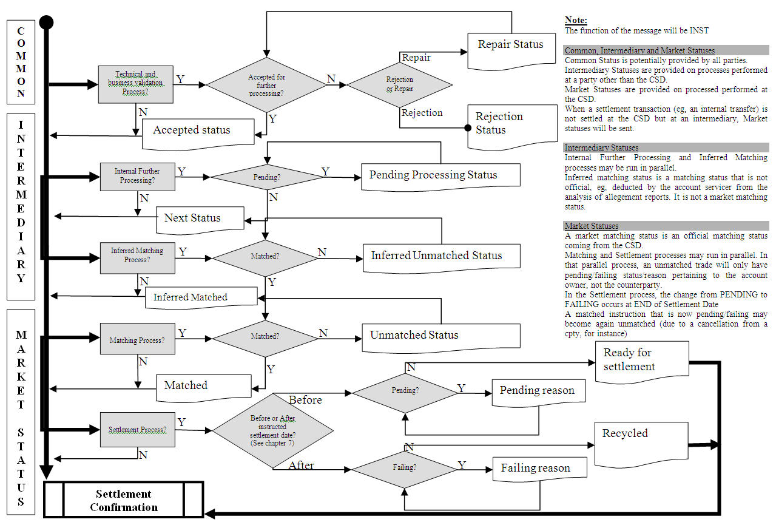

### Cancellation Request Status Advice

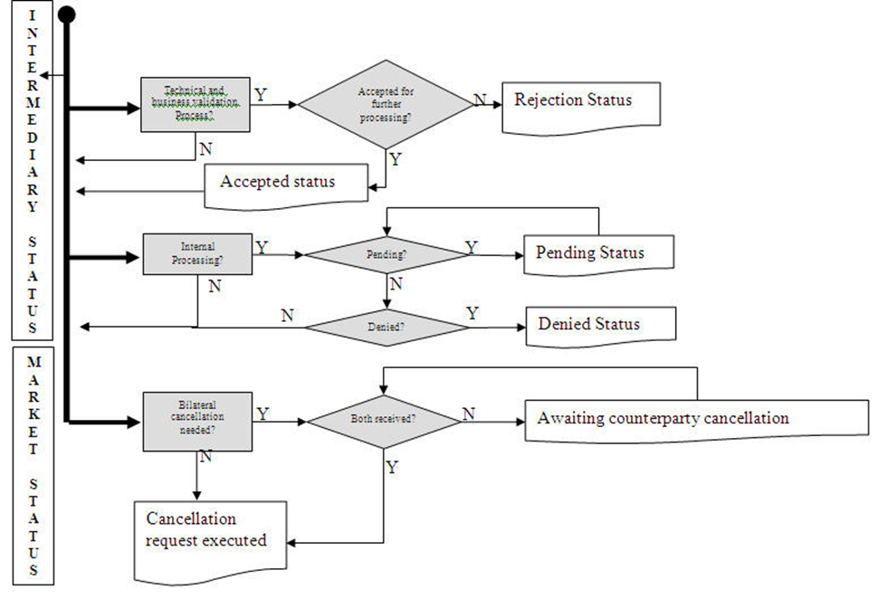

### Instruction Cancellation Advice

This covers the advice of a cancellation initiated by the executing party. This is part of the Instruction Status Advice process.

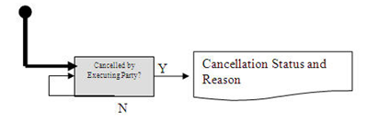

### Intra-position Instruction Status Advice

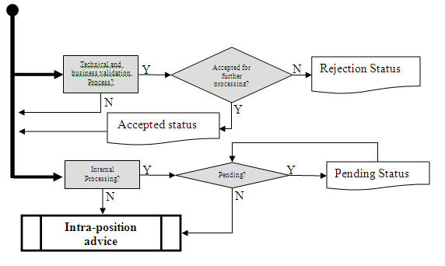

### Request for Status or Statement Status Advice

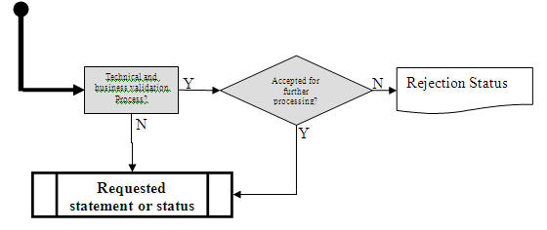

### Processing Change or Modification Status Advice

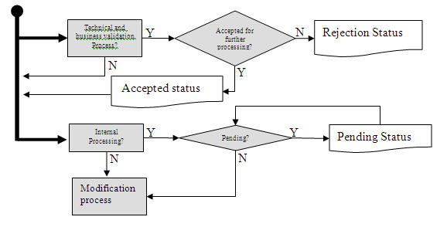

## Modification Process

Processing Changes – Hold and Release scenario



|  |  |  |
| --- | --- | --- |
| Step | Description | Initiator |
| Create instruction | Instruction of the original instruction with status on hold or released. | Instructing Party |
| Processing matching and settlement process | Not described in details, the focus is on hold/release. | Executing Servicing Party |
| Monitor matching and settlement process | Not described in details, the focus is on hold/release. | Instructing Party |
| Hold/release process needed | If the instruction needs to be released or held, go to Hold or Release Activity | Instructing Party |
| Hold or release? | If the instruction is on hold and need to be released, go to Process release instruction activity. If the instruction is released and need to be put on hold, go to Process hold instruction activity. | Instructing Party |
| Process release instruction | Release the on hold instruction. If the instruction was already released, no action | Executing Servicing Party |
| Process hold instruction | Hold the released instruction. If the instruction was already on hold, no action. | Executing/Servicing Party |
| Settled No/Yes | If NO, go to update status activity. If YES, go to settle trade activity.  Applies to all instructions, resulting from a split or not. | Instructing Party |
| Settled No/Yes | If NO, go to update status activity. If YES, go to settle trade activity.  Applies to all instructions, resulting from a split or not. | Executing Servicing Party |
| Update status | Update the status based on the instruction statuses received from the Executing/Servicing Party on both the original instruction and the hold/released instructions. This activity is not described in details. | Instructing Party |
| Update status | Update the status based on the processing, matching and settlement process on the original instruction, taking into account any hold/released instruction received. This activity is not described in details. | Executing Servicing Party |
| Settle trade | Settle the instruction in the system. Applies to all instructions, resulting from a split or not. | Instructing Party |
| Settle trade | Settle the instruction in the system. Applies to all instructions, resulting from a split or not. | Executing Servicing Party |

### Processing Changes – Other



|  |  |  |
| --- | --- | --- |
| Step | Description | Initiator |
| Request processing change | Request to modify a processing indicator on a transaction previously instructed. | Instructing Party |
| Process of processing change command | Validation of the processing change command. | Executing Servicing Party |
| Monitor processing change command | Monitoring of the status of the processing change command. | Instructing Party |
| Processed choice | If NO, go to reject activity. If YES, go to update original transaction activity. | Executing Servicing Party |
| Processed choice | If NO, STOP. If YES, go to update original transaction activity. | Instructing Party |
| Reject | Reject the processing change command and inform about the rejection. | Executing Servicing Party |
| Update the original transaction | Execute the requested processing change on the transaction for which the command was sent. | Executing Servicing Party |
| Update the original transaction | Reflect the requested processing change on the transaction for which the command was sent. | Instructing Party |
| Update status of original instruction | Update status of the original instruction if the processing change requires it (and inform about it). | Executing Servicing Party |
| Update status of original instruction | Update status of original instruction: Update status. | Instructing Party |

### Modification Request and Status Advice

#### Modification Process Prior To Settlement



|  |  |  |
| --- | --- | --- |
| Step | Description | Initiator |
| Create instruction | Instruction of the original instruction | Instructing Party |
| Processing, matching and settlement process | Not described in details, the focus is on the replacement/modification | Executing Servicing Party |
| Monitor matching and settlement process | Not described in details, the focus is on the modification. Go to Modification choice. | Instructing Party |
| Modification choice | If NO go to Monitor Matching and Settlement Process. If YES go to Request Modification. | Instructing Party |
| Request modification | Request to modify business data (could be several fields) of a transaction previously instructed. | Instructing Party |
| Validation of modification request | Validation of the Modification Request. | Executing Servicing Party |
| Validation choice | If NO, go to Reject. If YES, go to Counterparty Response choice. | Executing Servicing Party |
| Reject |  | Executing Servicing Party |
| Counterparty response choice | If NO, go to Monitor Modification Request, if YES go to Send Status Advice. | Executing Servicing Party |
| Review status | Go to Response choice | Counter Party |
| Response choice | If YES go to Provide a Response. If NO go to Monitor Modification Request (Executing/Servicing Party) | Counter Party |
| Provide a response | Provide a response to (Executing/Servicing Party) | Counter Party |
| Monitor modification request | Monitoring of the status of the Request. Go to Update choice. | Executing Servicing Party |
| Update choice | If NO, go to Provide Status on Modification, If YES, go to Update Original Transaction. | Executing Servicing Party |
| Monitor modification | Monitoring of the status of the Request. | Instructing Party |
| Provide status on modification request | Provide status of modification request and go back to Processing Matching and Settlement Process. | Executing Servicing Party |
| Validate choice | If NO, go to Pending choice. If YES, go to update original transaction activity. | Instructing Party |
| Pending choice | If NO, go back to Monitor Matching and Settlement Process. If YES, go back to Monitor Modification Request. | Instructing Party |
| Update the original transaction | Reflect modification on the transaction for which the command was sent and go back to the Monitor Matching and Settlement Process. | Instructing Party |
| Update the original transaction | Execute the requested modification on the transaction for which the request was sent and provide a status on the modification. Then go back to the Processing Matching and Settlement Process. | Executing Servicing Party |

#### Modification Process after Settlement



|  |  |  |
| --- | --- | --- |
| Step | Description | Initiator |
| Create instruction | Instruction of the original instruction | Instructing Party |
| Processing, matching and settlement process | Not described in details, the focus is on the replacement/modification | Executing Servicing Party |
| Modification process needed? | If the instruction needs to be replaced, go to Replace/Modify Activity | Instructing party |
| Request modification | Request to modify the data on a transaction previously settled. | Instructing Party |
| Process of modification request | Validation of the Modification Request. | Executing Servicing Party |
| Monitor modification request | Monitoring of the status of the Modification Request. | Instructing Party |
| Processed choice | If NO, go to Pending Choice. If YES, go to update original transaction activity. | Executing Servicing Party |
| Pending? | If NO, go to Reject. If YES. Go to Provide Status on Modification Request and Processed choice. | Executing Servicing Party |
| Processed choice | If NO, go to end. If YES, go back to Monitor Modification Request. | Instructing Party |
| Reject | Reject the Modification Request and inform about the rejection. | Executing Servicing Party |
| Pending choice | If NO, go to end. If YES, go back to Monitor Modification Request. | Instructing Party |
| Update original transaction | Execute the requested modification of the transaction for which the request was sent. | Executing Servicing Party |
| Provide status on modification request | Provide status of modification/replacement request and go back to Processing Matching and Settlement Process. | Executing Servicing Party |
| Other processes | Such as payment of a cash difference linked to a factor update. | Executing Servicing Party |

## Split Settlement Process

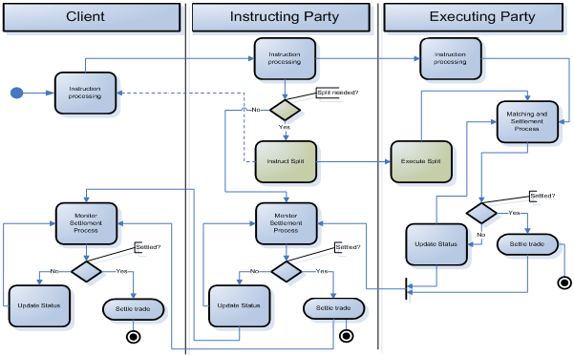

|  |  |  |
| --- | --- | --- |
| Step | Description | Initiator |
| Instruction processing | Activity that will be at the origin of the existence of the original instruction that will need to be split. This activity is not described here as it is not the focus of this MP. | Instructing Party Executing Party |
| Matching and settlement process | Not described in detail here. | Executing Party |
| Split needed Yes/No | If YES, that is, a pending instruction need to be split, the next step is the instruct split activity.  If NO, the pending instruction goes on its matching and settlement life cycle. | Instructing Party |
| Instruct split | Instruction of the split on a pending instruction. The split may be reported to the client.  It is to be noted that an instruction resulting from the split could be split itself, etc. | Instructing Party |
| Execute split | Execution of the split. The internal process performed to execute the split may differ from one system to another. It is not important as long as the communication regarding the split is harmonised. | Executing Party |
| Monitor matching and settlement process | This activity is not described in detail here. Applies to all instructions, resulting from a split or not. | Instructing Party |
| Monitor matching and settlement process | This activity is not described in detail here. Applies to all instructions, resulting from a split or not. | Executing Party |
| Settled Yes/No | If NO, go to update status activity. If YES, go to settle trade activity.  Applies to all instructions, resulting from a split or not. | |
| Update status | Update status (and inform about it). Applies to all instructions, resulting from a split or not. | |
| Settle instruction | Settle the instruction in the custody system. Applies to all instructions, resulting from a split or not. | |

## Allegement Process

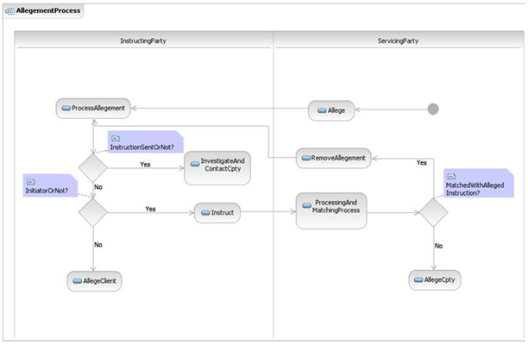

|  |  |  |
| --- | --- | --- |
| Step | Description | Initiator |
| Process allegement | Process the allegement and allegement removal received from the Executing/Servicing Party | Instructing Party |
| Allege | Following the receipt of counterparty instruction, an allegement is sent. | Executing Party |
| Instruction sent or not | If an instruction has been sent, go to Investigate and contact counterparty. If NO, go to Initiator or not? | Instructing Party |
| Investigate and contact counter party | Investigation of the issue and contact of counterparty if needed. | Instructing Party |
| Processing and matching process | not describe here. | Executing Party |
| Initiate or not | If the Instructing Party is the initiator of the instruction, then instruct. If not, allege client | Instructing Party |
| Matched with the alleged instruction | If yes, go to remove allegement. If not, go to allege counterparty | Executing Party |
| Instruct | Instruct the missing instruction. | Instructing Party |
| Remove allegement | Remove the allegement previously sent. | Executing Party |
| Allege client | Allege the next party in the chain, that is, the client. | Instructing Party |
| Allege counterparty | Allege the counterparty. | Executing Party |

## Reconciliation and Reporting Process

### Push Mode

This diagram shows the message flow between the instructing party, for example, a global custodian, and the executing/servicing party, for example, a sub-custodian.

Based on an account set up at a specified moment in time the executing/servicing party can send the following reports to the instructing party:

* SecuritiesBalanceCustodyReport
* SecuritiesBalanceAccounting Report
* SecuritiesTransactionPosting Report
* SecuritiesTransactionPendingReport
* SecuritiesSettlementTransactionAllegementReport
* IntraPositionMovementPostingReport

A third party may also be involved (for example a CSD) in the reporting/reconciliation process. In this scenario, the executing/servicing party sends the SecuritiesSettlementTransactionAudiTrailReport for each individual pending instruction to the third party. This message is used to advise of the history of all the statuses, modifications, replacement and cancellation of a specific transaction during its whole life cycle.



For the blue activities, see Instruction and Confirmation process.

The type of statement, its frequency, base, etc., is SLA based. Not all reporting is always provided.

|  |  |  |
| --- | --- | --- |
| Step | Description | Initiator |
| Reconciliation Process | Reconcile holdings (custody and accounting) and transactions based on the various statements received. | Instructing Party |
| Report transactions | Build statement of transactions and provide it to the instructing party | Executing Party |
| Report intra-position movements | Build statement of intra-position movements and provide it to the instructing party. | Executing Party |
| Report holdings (custody | Build statement of holdings, custody version, and provide it to the instructing party. | Executing Party |
| Investigate and solve breaks | Investigate of the issues found during the reconciliation process. This may lead to other processes such as cancellation requests, new instructions, settlement process, etc. | Instructing Party |
| Report holdings (accounting) | Build statement of holdings, accounting version, and provide it to the instructing party. | Executing Party |
| Report pending transactions | Build statement of pending transactions and provide it to the instructing party. | Executing Party |
| Report allegements | : Build statement of allegements and provide it to the instructing party | Executing Party |

### Pull Mode

This sequence diagram reports the messages flow between the instructing party (for example a global custodian) and the executing/servicing party (a sub-custodian for instance), upon request of the account owner, the executing/reporting party sends back a specific statement.

The instructing party requests a statement with a SecuritiesStatementQuery or requests a status on a securities transaction using the SecuritiesTransactionStatusQuery.

The executing/servicing party may send back a SecuritiesStatusOrStatementQueryStatusAdvice to provide a status on the request.

The executing/servicing party sends back the statement requested, for instance:

* SecuritiesBalanceCustodyReport
* SecuritiesBalanceAccountingReport
* SecuritiesTransactionPostingReport
* SecuritiesTransactionPendingReport
* SecuritiesSettlementTransactionAllegementReport
* IntraPositionMovementPostingReport

A third party may also be involved (for example a CSD) in the reporting/reconciliation process. In this scenario, the third party requests a detailed report on a pending securities transaction to the executing/servicing party.

The executing/servicing party may send back a SecuritiesStatusOrStatementQueryStatusAdvice to provide a status on the request.

The executing/servicing party sends back the SecuritiesTransactionAuditTrailReport to the third party.



|  |  |  |
| --- | --- | --- |
| Step | Description | Initiator |
| Request statement | Request statement to executing/reporting party. | Instructing Party |
| Process request | Technical and business validation of the request before further processing or not. | Executing Party |
| Processed Yes/No | If YES, that is, the request is valid, go to the Statement requested choice. If NO, the update status activity is done. | Executing Party |
| Statement requested | Base on statement requested; go to the requested reporting activity. | Executing Party |

## Cancellation Request Process



|  |  |  |
| --- | --- | --- |
| Step | Description | Initiator |
| Request cancellation | Request cancellation, based on an request received by a client or not. | Instructing Party |
| Process cancellation request | Technical and business validation of the details of the request before further processing or not. | Executing/Servicing Party |
| Processed Yes/No | If YES, that is, the instruction is ready for further processing, the next step is the cancellation process. It is understood that, though not shown on the diagram, a status update may also occur following a YES. If NO, the update status activity is done. | Executing/Servicing Party |
| Monitor cancellation request | Monitor the status of the cancellation request | Instructing Party |
| Cancellation process | Attempt the cancellation. | Executing/Servicing Party |
| Cancelled No/Yes | If NO, go to update status activity. If YES, go to cancel instruction activity. | Instructing Party |
| Cancelled No/Yes | If NO, go to update status activity. If YES, go to cancel instruction activity. | Executing/Servicing Party |
| Update status | Update status (and inform about it). | Instructing Party |
| Update status | Update status (and inform about it). | Executing/Servicing Party |
| Cancel instruction | Cancel the instruction in the system. | Instructing Party |
| Cancel instruction | Cancel the instruction in the system. | Executing/Servicing Party |

## Cancellation Advise Process

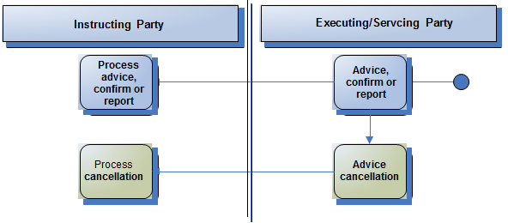

|  |  |  |
| --- | --- | --- |
| Step | Description | Initiator |
| Process advice, confirm or report | Process the advice, the confirm or the statement received from the Executing/Servicing Party | Instructing Party |
| Advice, confirm or report | The Executing/Servicing Party send a status advice, statement, allegement, confirmation, intra-position advice... | Executing/Servicing Party |
| Process cancellation | Process the cancellation advice received. | Instructing Party |
| Advice cancellation | The Executing/Servicing Party advice of the cancellation of a previously sent status advice, statement, allegement, confirmation, intra-position advice... | Executing/Servicing Party |

This does not cover the advice of the cancellation of an instruction previously received by the executing/ servicing party:

* for status on a cancellation request, it is covered by the cancellation request status reporting
* for instructions being cancelled by the Executing/Servicing Party or a third party, it is covered by the instruction status reporting.

## Reversal Advice Process

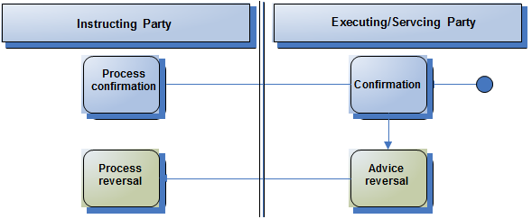

|  |  |  |
| --- | --- | --- |
| Step | Description | Initiator |
| Process confirm | Process the confirm received from the Executing/Servicing Party | Instructing Party |
| Confirm | The Executing/Servicing Party send a confirmation to the Instructing Party. | Executing/Servicing Party |
| Process cancellation | Process the reversal of the confirmation. | Instructing Party |
| Advice reversal | The Executing/Servicing Party advise the instructing party of the reversal the confirmation of a partial or full delivery or receipt of financial instruments, free or against of payment, physically or by book-entry. | Executing/Servicing Party |

## Portfolio Transfer Process



|  |  |  |
| --- | --- | --- |
| Step | Description | Initiator |
| Advise the move of positions | The customer informs the delivering custodian that it intends to move some or all of its positions to another custodian. The client also advised the receiving custodian of the move of positions. | Client |
| Process the request to receive | The receiving custodian processes the request | Executing/Servicing Party Receiving Custodian |
| Process the request to deliver | The delivering custodian processes the request | Executing Servicing Party Delivering Custodian |
| Send the receiving settlement details | The receiving custodian sends the settlement details to the delivering custodian. | Executing/Servicing Party Receiving Custodian |
| Send the delivering settlement details | The delivering custodian sends the settlement details to the receiving custodian. | Executing Servicing Party Delivering Custodian |
| Reconcile the delivering settlement details | The receiving custodian checks whether there are any differences with the delivering settlement details provided by the delivering custodian.  If Yes, the custodian will investigate with the customer. | Executing/Servicing Party Receiving Custodian |
| Reconcile the receiving settlement details | the delivering custodian check whether there are any differences with the receiving settlement details provided by the receiving custodian and also check any potential position breaks with the client ‘s books..  If Yes, the custodian will investigate with the customer. | Executing Servicing Party Delivering Custodian |
| Investigate breaks with the custodian and potentially advise new move of positions | The customer informs the delivering and receiving custodians of updated move of positions. | Client |
| If no then the custodian will | Instruct the Receives Free to the CSD. | Executing/Servicing Party Receiving Custodian |
| If no then the custodian will | If No, then the custodian will instruct the Deliveries Free to the CSD. | Executing Servicing Party Delivering Custodian |

## Transaction Generation Process

In this scenario, an executing/servicing party sends a SecuritiesSettlementTransactionGenerationNotification to an instructing party to advise the instructing party of a securities settlement transaction that has been generated/created by the executing/servicing party for the instructing party.

The reason for creation can range from the automatic transformation of pending settlement instructions following a corporate event to the recovery of an account owner transactions’ database initiated by its executing/servicing party.

# BusinessTransactions

This section describes the message flows based on the activity diagrams documented above. It shows the typical exchanges of information in the context of a BusinessTransaction.

The following conventions apply to all the Business Transaction diagrams:

* In green, the main communication requirements for this process.
* In black, the surrounding communication requirements.
* In grey boxes, the optional/potential surrounding communication requirements.

## Instruction and Confirmation

This diagram shows the messages flow between the instructing party and the executing/servicing party.

An instructing party (for example an investment manager), sends a SecuritiesSettlementTransactionInstruction to the executing/servicing party (a Global Custodian).

The executing/servicing party may send back to the instructing party a processing status and/or a settlement status referring to the state of the transaction using the SecuritiesSettlementTransactionStatusAdvice.

When the transaction settles at the executing/servicing Party, this latter sends a SecuritiesSettlementTransactionConfirmation to advise the instructing party that the settlement has taken place.

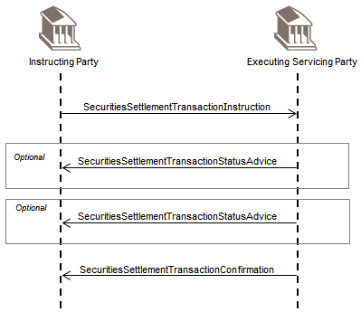

Intra-Position Instruction

This diagram shows the messages flow between the instructing party and the executing/servicing party.

An instructing party (for example a CSD participant), sends a IntraPositionMovementInstruction to the executing/servicing party (a CSD) to move some securities from one sub-balance to another or from one balance status to another.

The executing/servicing party may send back to the instructing party a processing status and/or a settlement status referring to the state of the intra-position movement.

When the intra-position movement is finalised at the executing/servicing party, this latter sends a IntraPositionMovementConfirmation to advise the instructing party that the movement of securities has taken place.

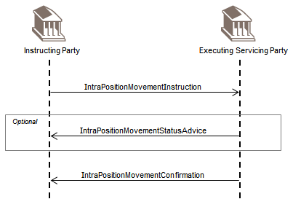

## Partial Settlement Confirmation

This diagram shows the messages flow between the instructing party and the executing/servicing party.

The partial settlement consists in settling one unique instruction in multiple phases, for example, 5000 on day 1, 10000 on day 2, until the original settlement instruction is fully settled. For partial settlements, the account servicers keep the original instruction and confirm/report settlement on parts of the original quantity and amount.

An instructing party (for examples a Broker) sends a SecuritiesSettlementTransactionInstruction to the executing/servicing party (a local custodian).

The executing/servicing party may send back to the instructing party a processing status and/or a settlement status referring to the state of the transaction using a SecuritiesSettlementTransactionStatusAdvice.

The transaction partially settles and the executing/servicing party sends a SecuritiesSettlementTransactionConfirmation referring only to the partially settled quantity.

The executing/servicing party may send back to the instructing party a settlement status referring to the state of the quantity which is still pending.

When the remaining quantity is settled then the executing/servicing party sends a SecuritiesSettlementTransactionConfirmation for that remaining quantity.

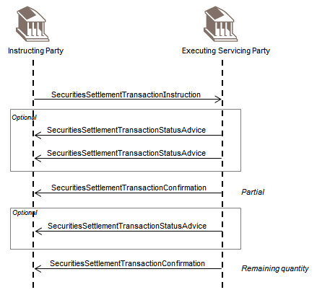

## Securities Financing

### Securities Financing Instruction and Confirmation

This section illustrates the instruction, status and confirmation of the opening and closing leg of a securities financing transaction and the relevant messages exchanged between the securities financing instructing party, the securities financing servicing party and the settlement executing party. The pure settlement of the opening and closing leg, when no securities financing information is required, would still be handled using regular settlement messages. The flows apply to repo/reverse repo, securities lending, securities borrowing, collateral in and collateral out (managed by a securities financing servicing party).

#### Three Parties

This diagram shows the messages flow between the securities financing instructing party, the securities financing servicing party and the settlement executing party.

The securities financing instructing party sends a SecuritiesFinancingInstruction to the securities financing servicing party.

The securities financing servicing party may send a processing and/or a settlement or matching status with a SecuritiesFinancingStatusAdvice to the securities financing instructing party for the opening leg.

The securities financing servicing party in turn sends a SecuritiesSettlementTransactionInstruction for the opening leg to the settlement executing party.

The settlement executing party may send a processing and/or a matching or settlement status with a

SecuritiesSettlementTransactionStatusAdvice to the securities financing servicing party for the opening leg.

The securities financing servicing party then sends a SecuritiesSettlementTransactionInstruction for the closing leg to the settlement executing party.

The settlement executing party may send a processing and/or a matching or settlement status with a

SecuritiesSettlementTransactionStatusAdvice to the securities financing servicing party for the closing leg.

The securities financing servicing party may send a processing and/or a settlement or matching status with a SecuritiesFinancingStatusAdvice to the securities financing instructing party for the closing leg.

When the opening leg settles, the settlement executing party sends a SecuritiesSettlementTransactionConfirmation to the securities financing servicing party. The securities financing servicing party then sends a SecuritiesFinancingConfirmation to the securities financing instructing party.

When the closing leg settles, the settlement executing party sends a SecuritiesSettlementTransactionConfirmation to the securities financing servicing party. The securities financing servicing party then sends a SecuritiesFinancingConfirmation to the securities financing instructing party.

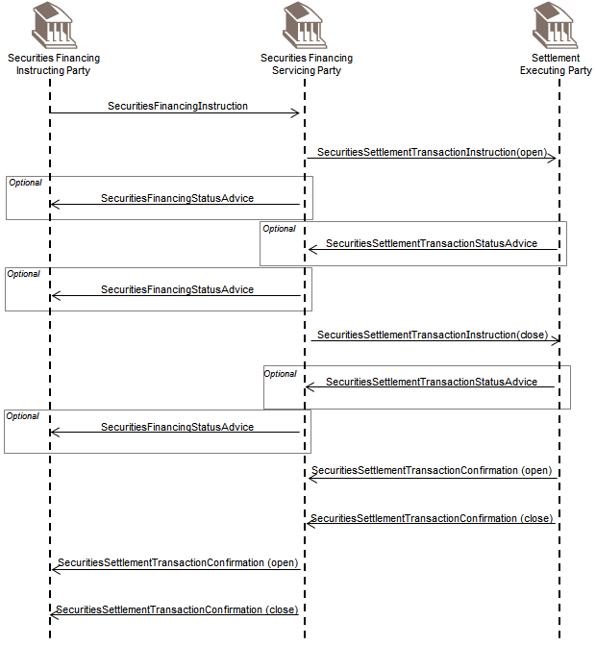

#### Two Parties

This diagram report the messages flow between the securities financing instructing party (a broker for example) and the securities financing servicing party/settlement executing party (a global custodian for instance).

The securities financing instructing party sends a SecuritiesFinancingInstruction to the securities financing servicing party/settlement executing party.

The securities financing servicing party/settlement executing party sets up both the closing and the opening leg of the securities financing.

The securities financing servicing party/settlement executing party may send a processing and/or a matching or settlement status to the securities financing instructing party for the opening and the closing legs.

When the opening and closing legs settle, the securities financing servicing party/settlement executing party sends a SecuritiesFinancingConfirmation to the securities financing instructing party.

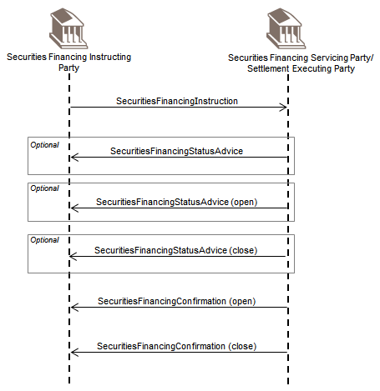

### Securities Financing Modification

#### Changes That Do Not Impact the Securities Position

This scenario applies to rate, date, amount, price closing leg changes not impacting the securities position, for example, repo call, repo rollover, repo rate change, securities lending return date change , etc... It illustrates the exchanges of messages between the Securities Financing Instruction Party, the Securities Financing Servicing Party and optionally the Settlement Executing party.

Three Parties

This diagram report the messages flow between the securities financing instructing party, the securities financing servicing party and the settlement executing party.

The securities financing Instructing party (a broker for example) sends a SecuritiesFinancingModificationInstruction to the securities financing servicing party (a custodian) to modify the rate of a repo for instance, on the closing leg.

The securities financing servicing party in turn sends a SecuritiesTransactionCancellationRequest to the settlement executing party (a CSD) and a new SecuritiesSettlementTransactionInstructing for the closing leg with the new rate.

The settlement executing party may send a processing and/or settlement or matching status to the securities financing servicing party with a SecuritiesSettlementStatusAdvice.

The securities financing servicing party may in turn send a processing and/or matching/settlement status to the securities financing instructing party with a SecuritiesFinancingStatusAdvice.

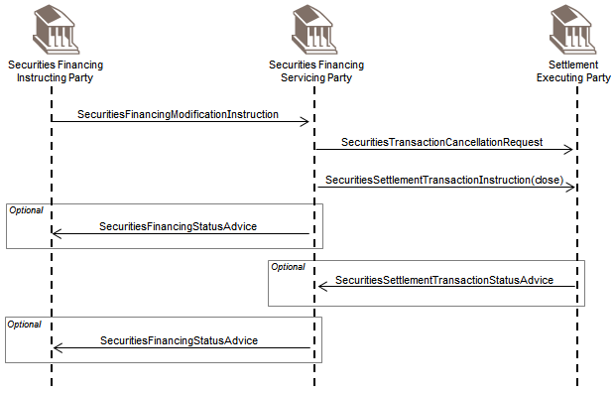

Two Parties

This diagram shows the messages flow between the securities financing instructing party and the securities financing servicing party/settlement executing party.

The Securities Financing Instructing party (a broker for example) sends a SecuritiesFinancingModificationInstruction to the securities financing servicing party/settlement executing party (a sub-custodian) to modify the rate of a repo for instance on the closing leg.

The securities financing servicing party/settlement executing party may send a processing and/or settlement or matching status for the instruction to the securities financing instructing party with a SecuritiesFinancingStatusAdvice.

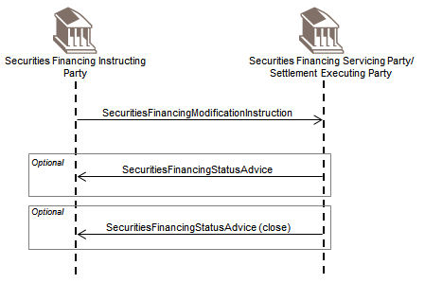

#### Changes That Do Impact the Securities Position

This refers to the substitution, top up and withdrawal flows that per SMPG current market practice are considered as simple position movements for which settlement instructions are used. Despite the scenarios will cover pure settlement movements, upon settlement of the change of positions not only a SecuritiesSettlementTransactionConfirmation will be sent out but also a Securities Financing Status Advice to advise of the position change impacting the securities financing transaction.

Three Parties

****A – Substitution****

The securities financing instructing party (a broker) sends two SecuritiesSettlementTransactionInstruction (receipt free and deliver free) to the Securities Financing servicing party (a custodian) to substitute the quantity of securities A with securities B.

The securities financing servicing party in turn sends two SecuritiesSettlementTransactionInstruction (receipt free and deliver free) to the settlement executing party (a CSD).

The settlement executing party may send a status on the receipt and the delivery to the securities financing servicing party with two SecuritiesSettlementTransactionStatusAdvice.

The securities financing servicing party may in turn send a status on the receipt and the delivery to the securities financing instructing party with two SecuritiesSettlementTransactionStatusAdvice.

When the substitution is completed, the settlement executing party sends two SecuritiesSettlementTransactionConfirmation for the receipt and the delivery to the securities financing servicing party.

The securities financing servicing party in turn sends two SecuritiesSettlementTransactionConfirmation for the receipt and the delivery to the securities financing instructing party .

The securities financing servicing party will also send a SecuritiesFinancingStatusAdvice to the securities financing instructing party to advise of the position change impacting the securities financing transaction.

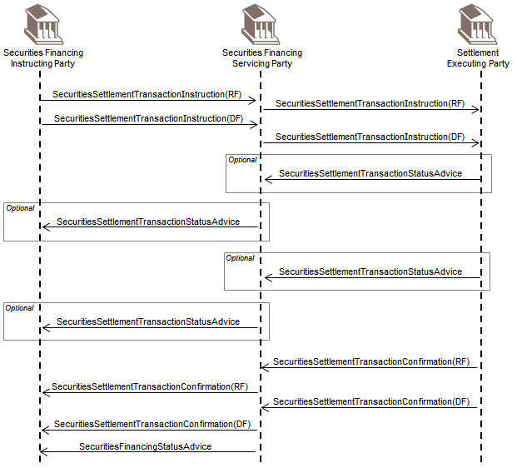

B – Top Up

The securities financing instructing party (a broker) sends a SecuritiesSettlementTransactionInstruction (deliver free) to the securities financing servicing party (a custodian) to increase the quantity of securities that serves as collateral.

The securities financing servicing party in turn sends a SecuritiesSettlementTransactionInstruction (deliver free) to the settlement executing party (a CSD).

The settlement executing party may send a status on the delivery to the securities financing servicing party with a SecuritiesSettlementTransactionStatusAdvice.

The securities financing servicing party may in turn send a status on the delivery to the securities financing instructing party with a SecuritiesSettlementTransactionStatusAdvice.

When the top up is completed, the settlement executing party sends a SecuritiesSettlementTransactionConfirmation for the delivery to the securities financing servicing party.

The securities financing servicing party in turn sends a SecuritiesSettlementTransactionConfirmation for the delivery to the securities financing instructing party.

The securities financing servicing party will also send a SecuritiesFinancingStatusAdvice to the securities financing instructing party to advise of the position change impacting the securities financing transaction.

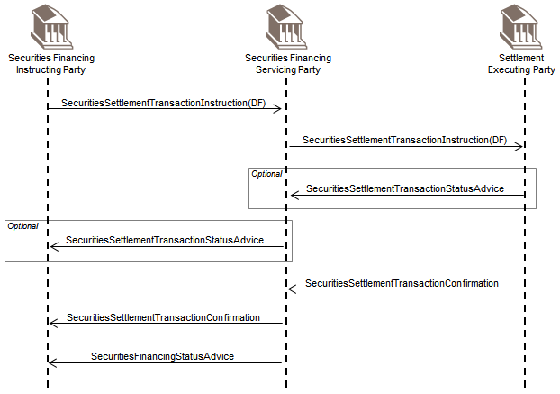

C – Withdrawal

The securities financing instructing party (a broker) sends a SecuritiesSettlementTransactionInstruction (receipt free) to the securities financing servicing party (a custodian) to decrease the quantity of securities that serves as collateral.

The securities financing servicing party in turn sends a SecuritiesSettlementTransactionInstruction (receipt free) to the settlement executing party (a CSD).

The settlement executing party may send a status on the receipt to the Securities Financing servicing party with a

SecuritiesSettlementTransactionStatusAdvice.

The securities financing servicing party may in turn send a status on the receipt to the securities financing instructing party with a SecuritiesSettlementTransactionStatusAdvice.

When the withdrawal is completed, the settlement executing party sends a

SecuritiesSettlementTransactionConfirmation for the receipt to the securities financing servicing party.

The securities financing servicing party in turn sends a SecuritiesSettlementTransactionConfirmation for the receipt to the securities financing instructing party.

The securities financing servicing party will also send a SecuritiesFinancingStatusAdvice to the securities financing instructing party to advise of the position change impacting the securities financing transaction.

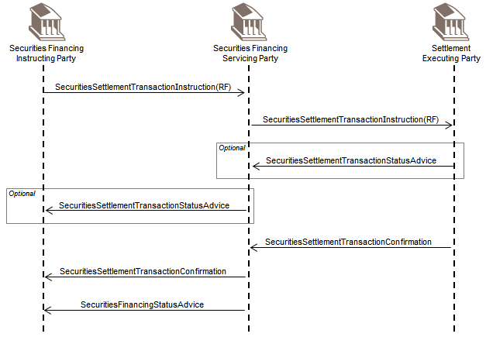

Two Parties

A – Substitution

The securities financing instructing party (a broker) sends two SecuritiesSettlementTransactionInstruction (receipt free and deliver free) to the securities financing servicing party/settlement executing party (a sub custodian) to substitute the a quantity of securities. The securities financing servicing party/settlement executing party may send a status on the receipt and the delivery to the securities financing instructing party with two SecuritiesSettlementTransactionStatusAdvice.

When the substitution is completed, the securities financing servicing party/settlement executing party sends two SecuritiesSettlementTransactionConfirmation for the receipt and the delivery to the securities financing instructing party.

The securities financing servicing party/settlement executing party will also send a SecuritiesFinancingStatusAdvice to the securities financing instructing party to advise of the position change impacting the securities financing transaction.

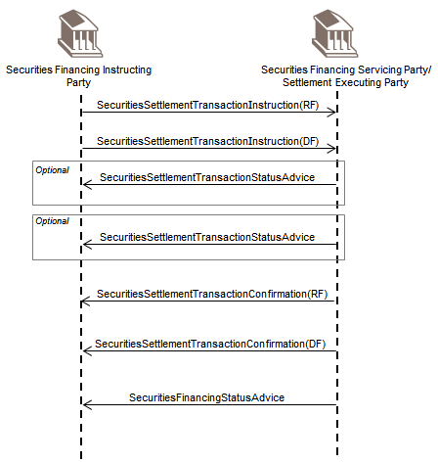

B – Top Up

The securities financing instructing party (a broker) sends a SecuritiesSettlementTransactionInstruction (deliver free) to the securities financing servicing party/settlement executing party (a sub-custodian) to increase the quantity of securities that serves as collateral.

The securities financing servicing party/settlement executing party may send a status on the delivery to the securities financing instructing party with a SecuritiesSettlementTransactionStatusAdvice.

When the top up is completed, the securities financing servicing party/settlement executing party sends a

SecuritiesSettlementTransactionConfirmation for the delivery to the securities financing instructing party with a SecuritiesSettlementTransactionConfirmation.

The securities financing servicing party/settlement executing party will also send a SecuritiesFinancingStatusAdvice to the securities financing instructing party to advise of the position change impacting the securities financing transaction.

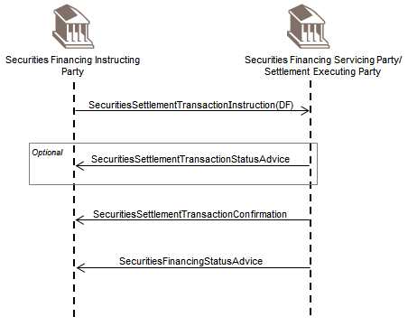

C – Withdrawal

The securities financing instructing party (a broker) sends a SecuritiesSettlementTransactionInstruction (receipt free) to the securities financing servicing party/settlement executing party (a sub-custodian) to decrease the quantity of securities that serve as collateral.

The securities financing servicing party/settlement executing party may send a status on the receipt to the securities financing instructing party with a SecuritiesSettlementTransactionStatusAdvice.

When the withdrawal is completed, the securities financing servicing party/settlement executing party sends a SecuritiesSettlementTransactionConfirmation for the receipt, to the securities financing instructing party.

The securities financing servicing party/settlement executing party will also send a SecuritiesFinancingStatusAdvice to the securities financing instructing party to advise of the position change impacting the securities financing transaction.

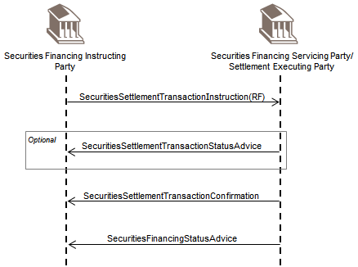

## Pair-Off Instruction

This diagram shows the messages flow between the instructing party and the executing/servicing party.

A pair-off consists of a buyback to offset and effectively liquidate a prior sale of securities or a sellback to offset and effectively liquidate a prior buy of securities.

An instructing party (for example and investment manager or a broker) sends a SecuritiesSettlementTransactionInstruction to the executing/servicing party (a global custodian).

The executing/servicing party may send back to the instructing party a processing status and/or a settlement status referring to the state of the transaction.

The instructing party sends the pair-off instruction for the previously sent instruction.

The executing/servicing party may send back to the instructing party a processing status and/or a settlement status referring to the state of the pair-off transaction.

The next potential step can be to cancel the paired-off instruction. This is linked to the matching/settlement process as the capacity to cancel or not will depend on the matching and the settlement status of the transactions to be cancelled.

Providing it was possible to cancel the transaction to be paired-off, the executing/servicing party will wire the cash difference (if net loss) or wait for the cash difference to be wired by the counterparty (in case of net gain).

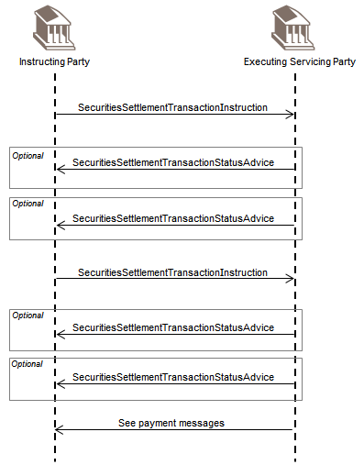

## Cash/Securities Split Instruction and Confirmation

This sequence diagram reports the messages flow between the instructing party, the securities/cash instruction executing/servicing party, the securities leg executing party and the cash leg executing party.

An instructing party (for example an investment manager), sends a SecuritiesSettlementTransactionInstruction (receive or delivery versus payment) to the securities/cash instruction executing/servicing party (a Global Custodian).

The securities/cash instruction executing/servicing party in turn sends a SecuritiesSettlementTransactionInstruction (receive or deliver free) to the securities leg executing party and a cash transfer to the cash leg executing party.

The securities leg executing party may send to the securities/cash instruction executing/servicing party a processing status and/or a settlement status referring to the state of the transaction. The later will then pass the information on to the instructing party.

When the transaction settles at the securities leg executing party, then this latter sends a

SecuritiesSettlementTransactionConfirmation to advise the securities/cash instruction executing/servicing party that the settlement has taken place. The securities/cash instruction executing/servicing party will then relay the information to the instructing party.

When the cash transfer takes place at the cash leg executing party, then this latter sends a security cash transfer confirmation to advise the securities/cash instruction executing/servicing party that the cash is transferred. The securities/cash instruction executing/servicing party will then relay the information to the instructing party.

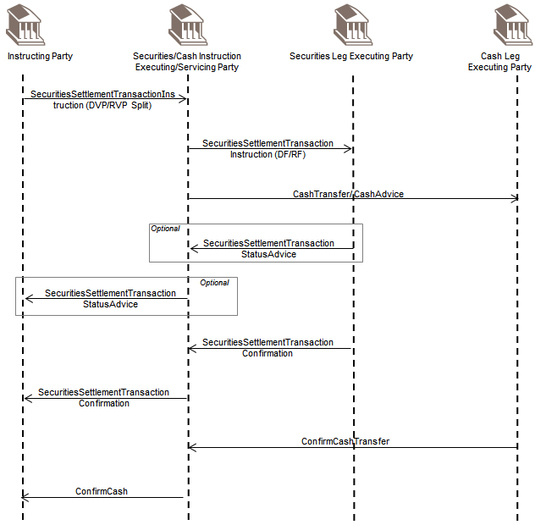

## Status Reporting

See the status reporting flows in above and below business transactions diagrams.

## Modification

The modification process covers the following processing changes and the reporting surrounding this process. These processing changes are:

* Automatic Borrowing Indicator: Specifies whether automatic borrowing needs to take place to achieve settlement.
* Retain Indicator: Specifies whether a failed instruction due to expire should be retained.
* Linking Indicator: Specifies what linkage action needs to be performed.
* Priority Indicator: Specifies the execution priority of the instruction.
* Partial Settlement Indicator: Specifies whether partial settlement is allowed.
* Securities Real-Time Gross Settlement Indicator: Specifies whether settlement is to be executed through an RTGS system.
* Hold Indicator: Specifies whether instruction is to be presented for settlement.

The scenarios below describe two examples of processing changes when:

* the on hold original instruction is being released and
* the released original instruction is being held then released.

### Processing Changes – Hold and Release

#### On Hold Original Instruction Being Released

This sequence diagram reports the messages flow between the instructing party and the executing/servicing party.

The instructing party originally sends a SecuritiesSettlementTransactionInstruction to the executing servicing party indicating that the transaction should not be release for settlement (hold indicator set to Y).

The executing/servicing party may send back to the instructing party a processing status and/or a settlement/matching status referring to the state of the transaction.

The instructing party then sends a SecuritiesSettlementConditionsModificationRequest, requesting the transaction to be released for settlement (hold indicator set to N).

Following the SecuritiesSettlementConditionsModificationRequest, the executing/servicing party may send back to the instructing party a processing status for the request with a SecuritiesSettlementConditionModificationStatusAdvice and/or a settlement/matching status referring to the state of the transaction using the SecuritiesSettlementStatus Advice.

When the transaction settles at the executing/servicing party, this latter sends a SecuritiesSettlementTransactionConfirmation to advise the instructing party that the settlement has taken place.

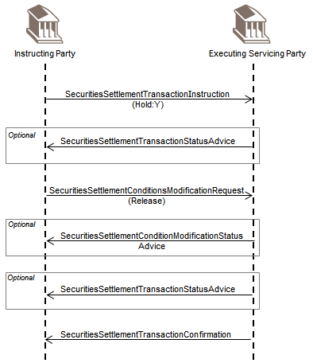

#### Processing Changes - Released Original Instruction Being Held Then Released

This sequence diagram reports the messages flow between the instructing party (for example a global custodian) and the executing/servicing Party (a CSD).

The instructing party originally sends a SecuritiesSettlementTransactionInstruction to the executing servicing party

with no on hold indicator, meaning that the instruction can be released for settlement.

The executing/servicing party may send back to the instructing party a processing status and/or a settlement status referring to the state of the transaction.

The instructing party then sends a SecuritiesSettlementConditionsModificationRequest to the executing servicing party indicating that the transaction should not be released for settlement anymore (hold indicator set to Y).

Following the SecuritiesSettlementConditionsModificationRequest, the executing/servicing party may send back to the instructing party a processing status for the request with a SecuritiesSettlementConditionsModificationStatusAdvice and/or a settlement status referring to the state of the transaction.

The instructing party then sends a SecuritiesSettlementConditionsModificationRequest, requesting the transaction to be released for settlement (hold indicator set to N).

Following the SecuritiesSettlementConditionsModificationRequest, the executing/servicing party may send back to the instructing party a processing status for the request with a SecuritiesSettlementConditionsModificationStatusAdvice and/or a settlement status referring to the state of the transaction.

When the transaction settles at the executing/servicing party, this latter sends a SecuritiesSettlementTransactionConfirmation to advise the instructing party that the settlement has taken place.

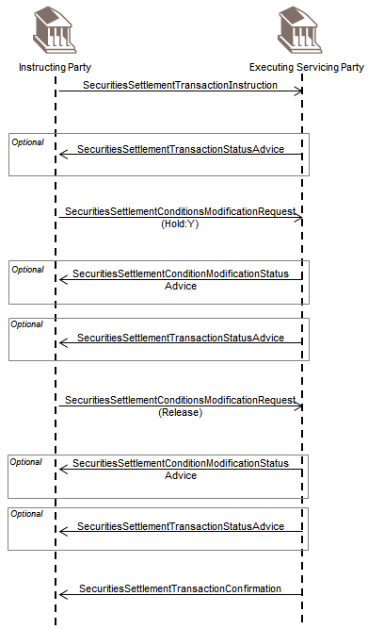

### Processing Changes for One or Multiple Transaction(s)

The modification process also covers:

* the processing change for one or multiple transaction(s) and the messages being exchanged between the instructing and the executing/servicing parties and
* the modification request that will give the possibility to an instructing party to modify or enrich a transaction without the necessity to cancel and resend a new one.

#### For One Transaction

This diagram shows the messages flow between the instructing party (for example a global custodian) and the executing/servicing party (a CSD).

The instructing party sends a SecuritiesSettlementConditionsModificationRequest to change the priority on one transaction.

The executing/servicing party may send back a SecuritiesSettlementConditionsModificationStatusAdvice to provide a processing status on the request for changing the priority.

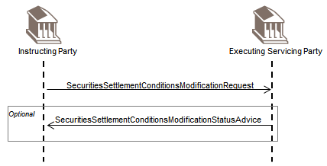

#### For Multiple Transactions

This diagram shows the messages flow between the instructing party (for example a global custodian) and the executing/servicing party (a CSD).

The instructing party sends a SecuritiesSettlementConditionsModificationRequest to change the priority on two transactions.

The executing/servicing party may send back a SecuritiesSettlementConditionModificationStatusAdvice for transaction 1 to provide a processing status on the request for changing the priority and/or a SecuritiesSettlementTransactionStatusAdvice.

The executing/servicing party may send back a SecuritiesSettlementConditionModificationStatusAdvice for transaction 2 to provide a processing status on the request for changing the priority and/or a SecuritiesSettlementTransactionStatusAdvice.

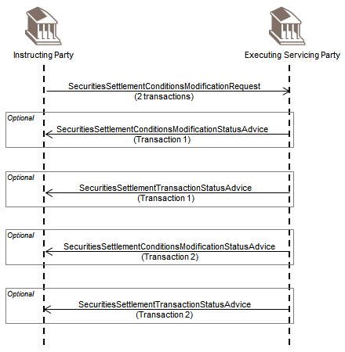

### Modification Request and Status Advice

#### Modification Process Prior Settlement Scenario

This is the scenario where the stock exchange/platform sends a trade confirmation to the CSD that generates the instruction. The CSD participant sends a modification message to enrich the pending instruction. Data that are generally enriched are safekeeping account, cash account and settlement date.

Note that in some markets (i.e. Finland and Sweden), stock exchange trades cannot be cancelled, they must settle. Therefore they can only be modified (or enriched).

This diagram shows the messages flow between the instructing party (for example a global custodian) and the executing/servicing party (a CSD) in addition to the counterparty's instructing party.

The instructing party sends a SecuritiesSettlementTransactionInstruction to the executing/servicing party. The same flow takes place on the counterparty's side.

The executing/servicing party may send back to the instructing party a processing status and/or a matching status referring to the state of the transaction using the SecuritiesSettlementTransactionStatusAdvice. The same flow takes place on the counterparty's side.

The instructing party sends a SecuritiesSettlementTransactionModificationRequest to the executing party to request the modification of business data.

The executing/servicing party may send back to the counterparty's instructing party a

SecuritiesSettlementTransactionStatusAdvice advising that the instructing party wants to modify a matched transaction (if affirmation from the counterparty's instructing party is required).

The counterparty's instructing party may send back to the executing/servicing party a

SecuritiesSettlementTransactionCounterpartyResponse to affirm or not the modification (that is to allow the account servicer to proceed or not with the modification request from the instructing party).

The executing/servicing party sends back to the instructing party a SecuritiesSettlementTransactionModificationRequestStatusAdvice to advise the status of the SecuritiesSettlementTransactionModificationRequest message.

The executing/servicing party may also send a processing status and/or a matching status referring to the state of the transaction using and a SecuritiesSettlementTransactionStatusAdvice.

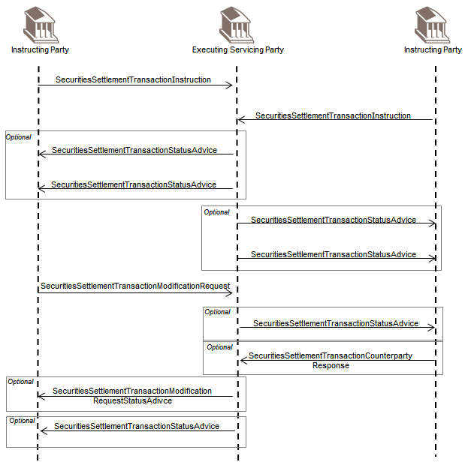

#### Modification Process Post Settlement Scenario

This scenario describes the modification after settlement of accounting data. In the case of a factor update, the instructing party must correct the factor, the net amount and provide cash details to move the money for the difference.

This sequence diagram reports the messages flow between the instructing party (for example a global custodian) and the executing/servicing party (a CSD).

The instructing party sends a SecuritiesSettlementTransactionInstruction to the executing/servicing party.

The executing/servicing party may send back to the instructing party a processing status and/or a matching status, referring to the state of the transaction using the SecuritiesSettlementTransactionStatusAdvice.

The executing/servicing party sends a SecuritiesSettlementTransactionConfirmation to the instructing party to confirm the settlement of the original instruction.

The instructing party sends a SecuritiesSettlementTransactionModificationRequest to the executing party to request the modification of accounting data.

The executing/servicing party sends back to the instructing party a SecuritiesSettlementTransactionModificationRequestStatusAdvice to advise the status of a SecuritiesSettlementModificationRequest message previously.

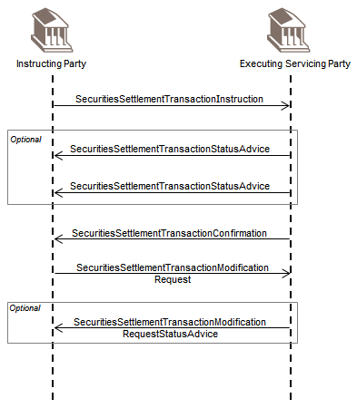

## Split Settlement

The split settlement consists (for an instructing/splitting party) in requesting the replacement of an existing instruction by two or more instructions. This is typically done by CSD Participants (unilaterally or bilaterally) to for example, enable the settlement of a client instruction that is short. Unilateral splitting is when only one party instructs the split. This happens for example in the UK.

### Bilateral Splitting

Bilateral splitting is when both parties to a trade must instruct and match for a split to take place. This happens for example in Switzerland.

This diagram shows the messages flow between the client, the instructing splitting party, the executing/servicing party in addition to the counterparty's client and instructing party.

A client sends a SecuritiesSettlementTransactionInstruction to the instructing/splitting party (for example a global custodian) which in turn sends the instruction to the executing/servicing party (a CSD). The same flow takes place on the counterparty's side.

The executing/servicing party may send back to the instructing party and in turn the client, a processing status and/or a settlement/matching status referring to the state of the transaction. The same flow takes place on the counterparty's side.

The instructing/splitting party sends a cancellation request to the executing/servicing party (and optionally advise their client on the status of this request) and replaces it with two new instructions. Again, the instructing party may advise the client of the status of the new instructions. The same flow takes place on the counterparty's side.

The executing/servicing party may send back to the instructing party and in turn the client a processing status and/or a settlement/matching status referring to the state for both transactions. The same flow takes place on the counterparty's side.

When the transactions settle at the executing/servicing party, this latter sends two

SecuritiesSettlementTransactionConfirmation to advise the instructing party and then in turn the client that the settlement has taken place. The same flow takes place on the counterparty's side.

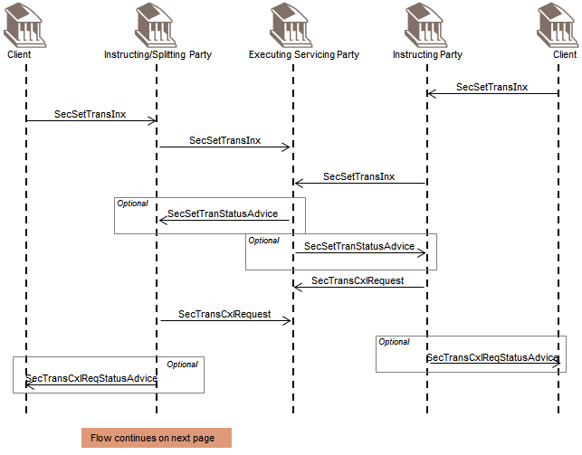

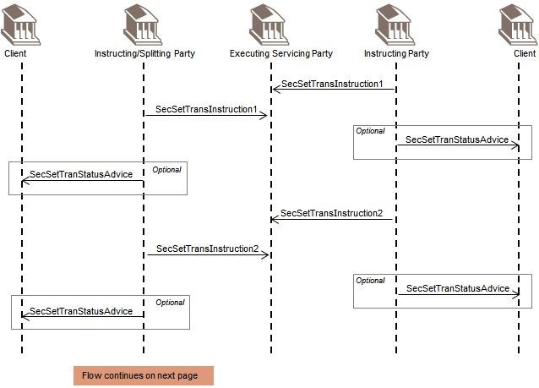

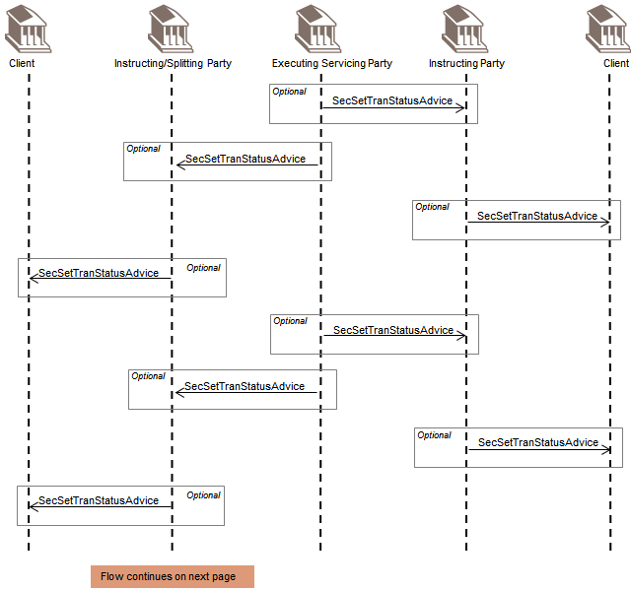

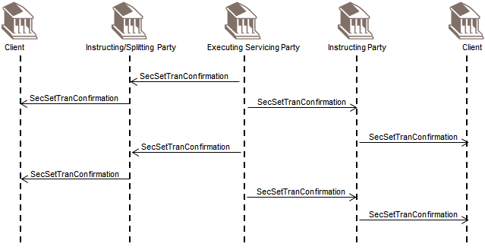

### Unilateral Splitting

Unilateral splitting is when only one party instructs the split. This happens, for example, in the UK and the US.

This diagram shows the messages flow between the client, the instructing splitting party, the executing/servicing party in addition to the counterparty's client and instructing party.

A client sends a SecuritiesSettlementTransactionInstruction to the instructing/splitting party (for example a global custodian) which in turn send the instruction to the executing/servicing party (a CSD). The same flow takes place on the counterparty's side.

The executing/servicing party may send back to the instructing party and in turn the client, a processing status and/or a settlement status referring to the state of the transaction. The same flow takes place on the counterparty's side.

The instructing/splitting party sends a SecuritieSettlementConditionModificationRequest to the executing/servicing party to request the splitting of the instruction in two. This can happen when the client sends an instruction for US government bonds with a quantity greater than 50 million which is not allowed on the US market.

The executing/servicing party then cancels the counterparty's transaction and replaces it with two new transactions.

The executing/servicing party may send back to the instructing party and in turn the client a processing status and/or a settlement/matching status referring to the state of the transaction. The same flow takes place on the counterparty's side.

When the transactions settle at the executing/servicing party, this latter sends two Security SettlementTransactionConfirmation to advise the instructing party and then in turn the client that the settlement has taken place. The same flow takes place on the counterparty's side.

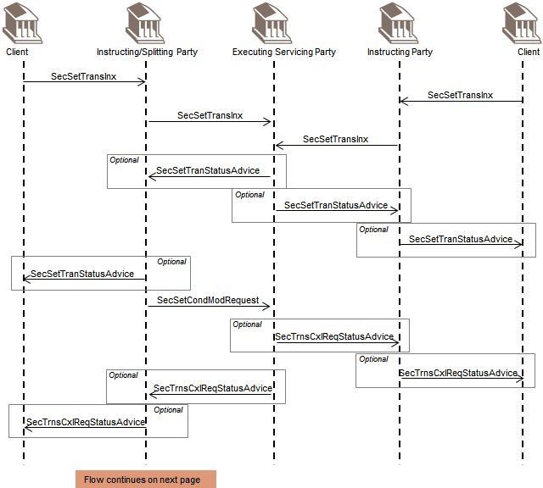

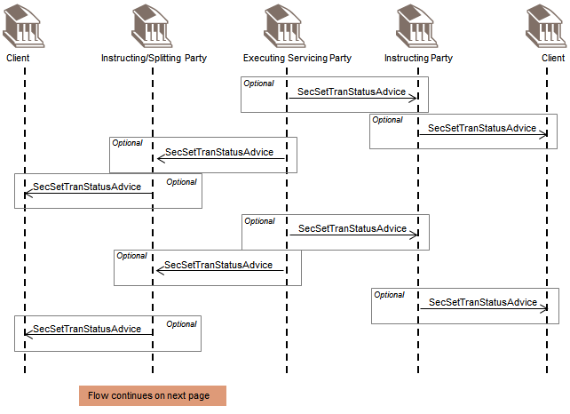

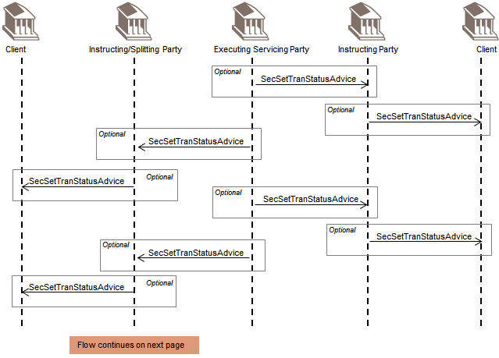

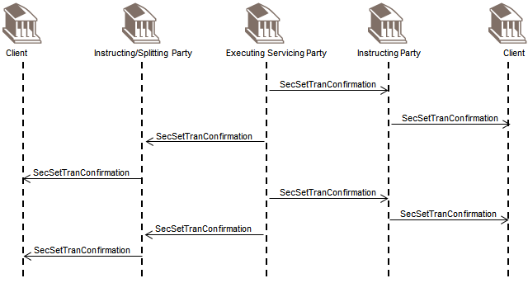

## Allegement

This diagram shows the messages flow between the alleged party, the executing/servicing party and the alleging party.

The instructing/alleging party sends a SecuritiesSettlementTransactionInstruction to the executing/servicing party.

The executing/servicing party sends a SecuritySettlementTransactionAllegementNotification to the instructing/alleged party since it could not find the corresponding instruction.

The instructing/alleged party may send back to the executing/servicing party a SecuritiesSettlementTransactionCounterpartyResponse to provide more information about the allegement received (for example, the rejection or acknowledgement of the allegement). The executing/servicing party sends a SecuritiesSettlementTransactionStatusAdvice to the alleging party.

The instructing/alleged party may send a SecuritiesSettlementTransactionInstruction to the executing/servicing party.

When the executing/servicing party has received the instruction from the alleged party and if the instruction matches the one received from the alleging party, the executing/servicing party sends a SecuritiesSettlementAllegementRemovalAdvice to the alleged party.

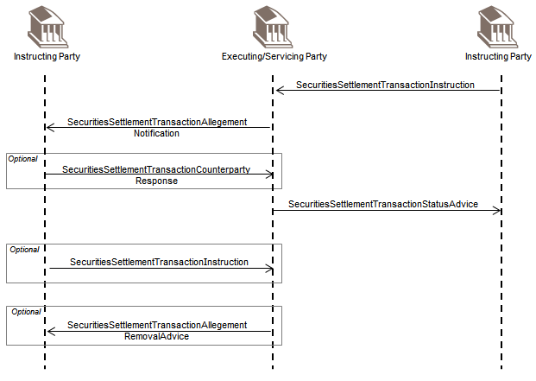

## Reconciliation and Reporting

This section describes the various reports an account servicer can provide to the account owner or designated agent.

For instance these reports can provide at a specified moment in time:

* the details of pending increases and decreases of holdings, for all or selected securities in a specified safekeeping account, for all or selected reasons why the transaction is pending
* the details of any increases and/or decreases of holdings, which may have occurred over a specified period of time, for all or a selected quantity of securities in the requested safekeeping account, which the account servicer
* holds for the account owner
* the quantity and identification of financial instruments that the account servicer maintains for the account owner
* the history of all the statuses, modifications, replacement and cancellation of a specific transaction during its whole life cycle

### Push Mode Scenario

This diagram shows the messages flow between the instructing party (for example a global custodian) and the executing/servicing party (a sub-custodian for instance).

Based on an account set up at a specified moment in time the executing/servicing party can send the following reports to the instructing party:

* SecuritiesBalanceCustodyReport
* SecuritiesBalanceAccountingReport
* SecuritiesTransactionPostingReport
* SecuritiesTransactionPendingReport
* SecuritiesSettlementTransactionAllegementReport
* IntraPositionMovementPostingReport

A third party may also be involved (for example a CSD) in the reporting/reconciliation process. In this scenario, the executing/servicing party sends the SecuritiesSettlementTransactionAudiTrailReport for each individual pending instruction to the third party. This message is used to advise of the history of all the statuses, modifications, replacement and cancellation of a specific transaction during its whole life cycle.

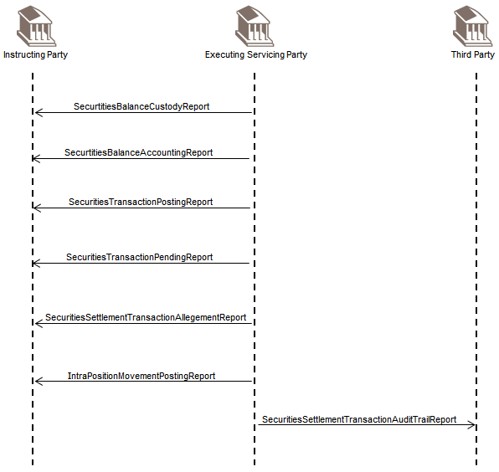

### Pull Mode Scenario

This diagram shows the messages flow between the instructing party (for example a global custodian) and the executing/servicing party (a sub-custodian for instance), upon request of the account owner, the executing/reporting party sends back a specific statement.

The instructing party requests a statement with a SecuritiesStatementQuery or requests a status on a securities transaction using the SecuritiesTransactionStatusQuery.

The executing/servicing party may send back a SecuritiesStatusOrStatementQueryStatusAdvice to provide a status on the request.

The executing/servicing party sends back the statement requested, for instance:

* SecuritiesBalanceCustodyReport
* SecuritiesBalanceAccountingReport
* SecuritiesTransactionPostingReport
* SecuritiesTransactionPendingReport
* SecuritiesSettlementTransactionAllegementReport
* IntraPositionMovementPostingReport

A third party may also be involved (for example a CSD) in the reporting/reconciliation process. In this scenario, the third party requests a detailed report on a pending securities transaction to the executing/servicing party.

The executing/servicing party may send back a SecuritiesStatusOrStatementQueryStatusAdvice to provide a status on the request.

The executing/servicing party sends back the SecuritiesTransactionAuditTrailReport to the third party.

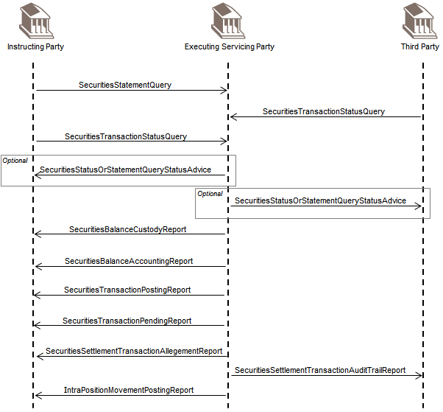

## Cancellation Request

This diagram shows the messages flow between the instructing party and the servicing/executing party.

This flow describes the process of cancelling any instruction. The instructing party (for example an investment manager) could request to cancel for example, a settlement transaction, an intra-position movement, a securities financing transaction to the executing/servicing party (a custodian for instance).

The instructing party sends any kind of instruction as described above.

Then the instructing party sends a SecuritiesTransactionCancellationRequest to the executing/servicing party.

The executing servicing party may update the instructing party of the status of its request with a SecuritiesTransactionCancellationRequestStatusAdvice.

When the cancellation is completed the executing/servicing party sends back a SecuritiesTransactionCancellationRequestStatusAdvice with the status completed.

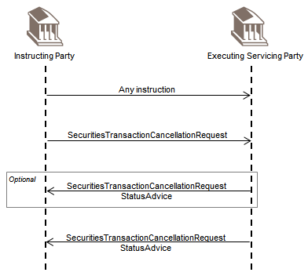

## Cancellation Advice

This diagram shows the messages flow between the instructing party and the executing/servicing party.

This message is used to inform of the cancellation of a securities message previously sent by an account executing/servicing party (for example a CSD) to the instructing party (a sub-custodian).

This does not cover the advice of the cancellation of an instruction previously received by the executing/servicing party:

* for status on a cancellation request, it is covered by the cancellation request status reporting
* for instructions being cancelled by the executing/servicing party or a third party, it is covered by the reversal advice process described below.

The executing/servicing party sends any type of advice or statement (for example a status advice or a report). Then the executing/servicing party sends a SecuritiesMessageCancellationAdvice if the original message was sent by mistake for instance.

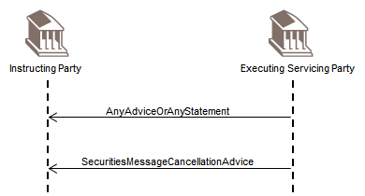

## Reversal Advice

This diagram shows the messages flow between the instructing party and the executing/servicing party.

The executing party sends a SecuritiesSettlementTransactionReversalAdvice to an instructing party to reverse the confirmation of a partial or full delivery or receipt of financial instruments, free or against of payment, physically or by book-entry.

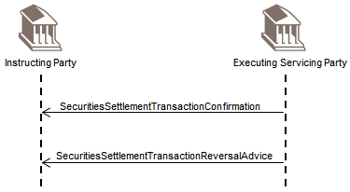

## Portfolio Transfer

This diagram shows the messages flow between two executing/servicing parties that exchange settlement details information during a retail or institutional client portfolio transfer.

By exchange of transfer settlement details, it is understood the providing of, by the delivering account servicer to the receiving account servicer, the settlement details (for example, trade date, settlement date, delivering settlement chain, quantities) of the individual transfers that will take place during a full or partial portfolio transfer.

This delivering account servicer message may also include, for validation, the receiving settlement chain as provided by the client. In case the receiving settlement chain is not available to the delivering account servicer, the receiving account servicer may in return provide to the delivering account servicer the receiving settlement chain using the same message.

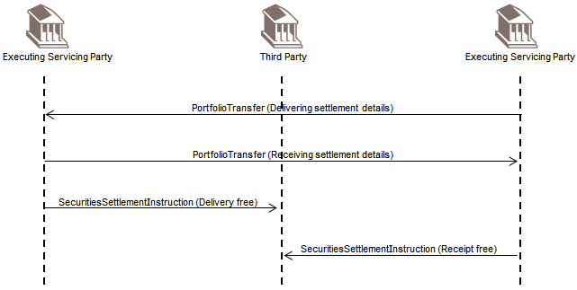

## Transaction Generation

In this scenario, an executing/servicing party sends a SecuritiesSettlementTransactionGenerationNotification to an instructing party to advise the instructing party of a securities settlement transaction that has been generated/created by the executing/servicing party for the instructing party.

The reason for creation can range from the automatic transformation of pending settlement instructions following a corporate event to the recovery of an account owner transactions' database initiated by its executing/servicing party.

# Business Examples

This section describes business examples of the use of the various MessageDefinitions.

## SecuritiesBalanceCustodyReport semt.002.001.11

Description

The Securities Balance Custody Report message (semt.002.001.09) is sent by the account servicer (Dresdner Bank London (DRESGB2L)), to the account owner (Dresdner Bank Frankfurt (DRESDEFF) for account 222S, to report the holding as of 15 January 2019.

Business Data

General Information

Number of pages: 1

Statement Date: 15/01/2019

Frequency: daily

Update type: complete

Statement Basis: Settled

Activity indicator: true

Sub Account Indicator: false

Account and Balances

Safekeeping Account: 222S

GB0987654321 short of 4,000,000 aggregate balance

GB0000987654 short of 6,000,000 aggregate balance

GB0000000123 short of 2,000 aggregate balance

GB0000123456 short of 70,000 aggregate balance, sub-balance of 15,000 out on loan securities that can be recalled automatically (available)

Message Instance

<SctiesBalCtdyRpt>

<Pgntn>

<PgNb>1</PgNb>

<LastPgInd>true</LastPgInd>

</Pgntn>

<StmtGnlDtls>

<StmtDtTm>

<Dt>2019-01-15</Dt>

</StmtDtTm>

<Frqcy>

<Cd>DAIL</Cd>

</Frqcy>

<UpdTp>

<Cd>COMP</Cd>

</UpdTp>

<StmtBsis>

<Cd>SETT</Cd>

</StmtBsis>

<ActvtyInd>true</ActvtyInd>

<SubAcctInd>false</SubAcctInd>

</StmtGnlDtls>

<SfkpgAcct>

<Id>222S</Id>

</SfkpgAcct>

<BalForAcct>

<FinInstrmId>

<ISIN>GB0987654321</ISIN>

</FinInstrmId>

<AggtBal>

<ShrtLngInd>SHOR</ShrtLngInd>

<Qty>

<Qty>

<Qty>

<FaceAmt>4000000</FaceAmt>

</Qty>

</Qty>

</Qty>

</AggtBal>

</BalForAcct>

<BalForAcct>

<FinInstrmId>

<ISIN>GB0000987654</ISIN>

</FinInstrmId>

<AggtBal>

<ShrtLngInd>SHOR</ShrtLngInd>

<Qty>

<Qty>

<Qty>

<FaceAmt>6000000</FaceAmt>

</Qty>

</Qty>

</Qty>

</AggtBal>

</BalForAcct>

<BalForAcct>

<FinInstrmId>

<ISIN>GB0000000123</ISIN>

</FinInstrmId>

<AggtBal>

<ShrtLngInd>SHOR</ShrtLngInd>

<Qty>

<Qty>

<Qty>

<Unit>2000</Unit>

</Qty>

</Qty>

</Qty>

</AggtBal>

</BalForAcct>

<BalForAcct>

<FinInstrmId>

<ISIN>GB0000123456</ISIN>

</FinInstrmId>

<AggtBal>

<ShrtLngInd>SHOR</ShrtLngInd>

<Qty>

<Qty>

<Qty>

<Unit>70000</Unit>

</Qty>

</Qty>

</Qty>

</AggtBal>

<BalBrkdwn>

<SubBalTp>

<Cd>LOAN</Cd>

</SubBalTp>

<Qty>

<QtyAndAvlbty>

<Qty>

<Unit>15000</Unit>

</Qty>

<AvlbtyInd>true</AvlbtyInd>

</QtyAndAvlbty>

</Qty>

</BalBrkdwn>

</BalForAcct>

</SctiesBalCtdyRpt>

## SecuritiesBalanceAccountingReport semt.003.001.11

Description

The Securities Balance Accounting Report message (semt.003.001.09) is sent by the account servicer (Dresdner Bank London (DRESGB2L)) , to the account owner (Dresdner Bank Frankfurt (DRESDEFF) for account 222S , to report the holding as of 15 January 2019.

Business Data

General Information

Number of pages: 1

Statement Date: 15/01/2019

Frequency: daily

Update type: complete

Statement Basis: Traded

Activity indicator: true

Audited Indicator: True

Sub Account Indicator: false

Account and Balances

Safekeeping Account: 222S

Financial Instrument Identification for each positions:

GB0987654321 long of 4,000,000 aggregate balance

Price Type: Market

Value Type: Par value

Rate: 100.2

Holding value of the position in account base currency: GBP 12,458,799

GB0000987654 long of 6,000,000 aggregate balance

Price Type: Market

Value Type: Par value

Par Value Rate: 102

Holding value of the position in account base currency: GBP 6,012,000

GB0000000123 long of 2,000 aggregate balance

Price Type: Market

Value Type: Par value

Par Value Amount: GBP 124.23

Holding value of the position in account base currency: GBP 248,460

GB0000123456 long of 70,000 aggregate balance

Price Type: Market

Value Type: Par value

Par Value Amount: GBP 101

Holding value of the position in account base currency: GBP 70,700

Total Holding Value of the Statement in account base currency: GBP 12,456,789

Message Instance

<SctiesBalAcctgRpt>

<Pgntn>

<PgNb>1</PgNb>

<LastPgInd>true</LastPgInd>

</Pgntn>

<StmtGnlDtls>

<StmtDtTm>

<Dt>2019-01-15</Dt>

</StmtDtTm>

<Frqcy>

<Cd>DAIL</Cd>

</Frqcy>

<UpdTp>

<Cd>COMP</Cd>

</UpdTp>

<StmtBsis>

<Cd>TRAD</Cd>

</StmtBsis>

<ActvtyInd>true</ActvtyInd>

<AudtdInd>true</AudtdInd>

<SubAcctInd>false</SubAcctInd>

</StmtGnlDtls>

<SfkpgAcct>

<Id>222S</Id>

</SfkpgAcct>

<BalForAcct>

<FinInstrmId>

<ISIN>GB0987654321</ISIN>

</FinInstrmId>

<AggtBal>

<ShrtLngInd>LONG</ShrtLngInd>

<Qty>

<Qty>

<Qty>

<FaceAmt>4000000</FaceAmt>

</Qty>

</Qty>

</Qty>

</AggtBal>

<PricDtls>

<Tp>

<Cd>MRKT</Cd>

</Tp>

<Val>

<Rate>100.2</Rate>

</Val>

<ValTp>

<ValTp>PARV</ValTp>

</ValTp>

</PricDtls>

<AcctBaseCcyAmts>

<HldgVal>

<Amt Ccy="GBP">12458799</Amt>

<Sgn>true</Sgn>

</HldgVal>

</AcctBaseCcyAmts>

</BalForAcct>

<BalForAcct>

<FinInstrmId>

<ISIN>GB0000987654</ISIN>

</FinInstrmId>

<AggtBal>

<ShrtLngInd>LONG</ShrtLngInd>

<Qty>

<Qty>

<Qty>

<FaceAmt>6000000</FaceAmt>

</Qty>

</Qty>

</Qty>

</AggtBal>

<PricDtls>

<Tp>

<Cd>MRKT</Cd>

</Tp>

<Val>

<Rate>102</Rate>

</Val>

<ValTp>

<ValTp>PARV</ValTp>

</ValTp>

</PricDtls>

<AcctBaseCcyAmts>

<HldgVal>

<Amt Ccy="GBP">6012000</Amt>

<Sgn>true</Sgn>

</HldgVal>

</AcctBaseCcyAmts>

</BalForAcct>

<BalForAcct>

<FinInstrmId>

<ISIN>GB0000000123</ISIN>

</FinInstrmId>

<AggtBal>

<ShrtLngInd>LONG</ShrtLngInd>

<Qty>

<Qty>

<Qty>

<Unit>2000</Unit>

</Qty>

</Qty>

</Qty>

</AggtBal>

<PricDtls>

<Tp>

<Cd>MRKT</Cd>

</Tp>

<Val>

<Amt Ccy="GBP">124.23</Amt>

</Val>

<ValTp>

<ValTp>PARV</ValTp>

</ValTp>

</PricDtls>

<AcctBaseCcyAmts>

<HldgVal>

<Amt Ccy="GBP">248460</Amt>

<Sgn>true</Sgn>

</HldgVal>

</AcctBaseCcyAmts>

</BalForAcct>

<BalForAcct>

<FinInstrmId>

<ISIN>GB0000123456</ISIN>

</FinInstrmId>

<AggtBal>

<ShrtLngInd>LONG</ShrtLngInd>

<Qty>

<Qty>

<Qty>

<Unit>70000</Unit>

</Qty>

</Qty>

</Qty>

</AggtBal>

<PricDtls>

<Tp>

<Cd>MRKT</Cd>

</Tp>

<Val>

<Rate>101</Rate>

</Val>

<ValTp>

<ValTp>PARV</ValTp>

</ValTp>

</PricDtls>

<AcctBaseCcyAmts>

<HldgVal>

<Amt Ccy="GBP">70700</Amt>

<Sgn>true</Sgn>

</HldgVal>

</AcctBaseCcyAmts>

</BalForAcct>

<AcctBaseCcyTtlAmts>

<TtlHldgsValOfStmt>

<Amt Ccy="GBP">12456789</Amt>

<Sgn>true</Sgn>

</TtlHldgsValOfStmt>

</AcctBaseCcyTtlAmts>

</SctiesBalAcctgRpt>

## IntraPositionMovementInstruction semt.013.001.06

Description

On the 15 January 2019, the account owner Dresdner Bank Frankfurt DRESDEFF of account 222S, requests its sub-custodian Dresdner Bank London (DRESGB2L) to move securities from the available to the restricted sub-balance. This is done with the IntraPositionMovementInstruction (semt.013.001.04).

Business Data

Transaction Identification: FRTJ123REG1

Safekeeping Account: 222S

Financial Instrument: GB0987654321

Position to be moved: 4,000,000 from the available to the restricted balance settlement

Date: 15/01/2019

Message Instance

<IntraPosMvmntInstr>

<TxId>FRTJ123REG1</TxId>

<SfkpgAcct>

<Id>222S</Id>

</SfkpgAcct>

<FinInstrmId>

<ISIN>GB0987654321</ISIN>

</FinInstrmId>

<IntraPosDtls>

<SttlmQty>

<FaceAmt>4000000</FaceAmt>

</SttlmQty>

<SttlmDt>

<Dt>2019-01-15</Dt>

</SttlmDt>

<BalFr>

<Tp>

<Cd>AVAI</Cd>

</Tp>

</BalFr>

<BalTo>

<Tp>

<Cd>RSTR</Cd>

</Tp>

</BalTo>

</IntraPosDtls>

</IntraPosMvmntInstr>

## IntraPositionMovementStatusAdvice semt.014.001.07

Description

On the 15 January 2019, the account servicer, Dresdner Bank London (DRESGB2L), advises the account owner Dresdner Bank Frankfurt (DRESDEFF) of the status of the previously requested Intra-Position Movement Instruction. This is done with the IntraPositionMovementStatusAdvice (semt.014.001.05).

Business Data

Account Owner Transaction Identification: FRTJ123REG1

Processing Status: Acknowledged/Accepted (no specific reason

Safekeeping Account: 222s

Financial Instrument: GB0987654321

Face Amount: 4,000,000

Settlement Date: 15/01/2019

Position moved: 4,000,000 from the available to the restricted balance

Message Instance

<IntraPosMvmntStsAdvc>

<TxId>

<AcctOwnrTxId>FRTJ123REG1</AcctOwnrTxId>

</TxId>

<PrcgSts>

<AckdAccptd>

<NoSpcfdRsn>NORE</NoSpcfdRsn>

</AckdAccptd>

</PrcgSts>

<TxDtls>

<SfkpgAcct>

<Id>222S</Id>

</SfkpgAcct>

<FinInstrmId>

<ISIN>GB0987654321</ISIN>

</FinInstrmId>

<SttlmQty>

<FaceAmt>4000000</FaceAmt>

</SttlmQty>

<SttlmDt>

<Dt>2019-01-15</Dt>

</SttlmDt>

<BalFr>

<Cd>AVAI</Cd>

</BalFr>

<BalTo>

<Cd>RSTR</Cd>

</BalTo>

</TxDtls>

</IntraPosMvmntStsAdvc>

## IntraPositionMovementConfirmation semt.015.001.09

Description

On the 15 January 2019,the account servicer, Dresdner Bank London (DRESGB2L), sends to its customers Dresdner Bank Frankfurt (DRESDEFF) an Intra-Position Movement Confirmation (semt.015.001.06). It is used to confirm the previously requested securities movement.

Business Data

Transaction Identification: FRTJ123REG1

Safekeeping Account: 222S

Financial Instrument: GB0987654321

Position moved: 4,000,000 from the available to the restricted balance

Settlement Date: 15/01/2019

Message Instance

<IntraPosMvmntConf>

<AddtlParams>

<AcctOwnrTxId>FRTJ123REG1</AcctOwnrTxId>

</AddtlParams>

<SfkpgAcct>

<Id>222S</Id>

</SfkpgAcct>

<FinInstrmId>

<ISIN>GB0987654321</ISIN>

</FinInstrmId>

<IntraPosDtls>

<SttldQty>

<FaceAmt>4000000</FaceAmt>

</SttldQty>

<SttlmDt>

<Dt>2019-01-15</Dt>

</SttlmDt>

<BalFr>

<Tp>

<Cd>AVAI</Cd>

</Tp>

</BalFr>

<BalTo>

<Tp>

<Cd>RSTR</Cd>

</Tp>

</BalTo>

</IntraPosDtls>

</IntraPosMvmntConf>

## IntraPositionMovementPostingReport semt.016.001.09

Description

On the 15 January 2019, the account servicer, Dresdner Bank London (DRESGB2L), sends to its customers Dresdner Bank Frankfurt (DRESDEFF) an Intra-Position Movement Posting Report (semt.016.001.06). It is used to confirm the previously requested securities movements (here there is only one) for a specific period of time.

Business Data

Number of Pages: 1

Report Number: 125

Statement period from 14/01/2019 to 15/01/2019

Frequency of the Report: daily

Update Type: Complete

Activity Indicator: true

Safekeeping Account: 222S

Account Owner Transaction Id: FRTJ123REG1

Financial Instrument: GB0987654321

Position moved: 4,000,000 from the available to the restricted balance

Settlement Date:15/01/2019

Message Instance

<IntraPosMvmntPstngRpt>

<Pgntn>

<PgNb>1</PgNb>

<LastPgInd>true</LastPgInd>

</Pgntn>

<StmtGnlDtls>

<RptNb>

<Shrt>125</Shrt>

</RptNb>

<StmtPrd>

<FrDtToDt>

<FrDt>2019-01-14</FrDt>

<ToDt>2019-01-15</ToDt>

</FrDtToDt>

</StmtPrd>

<Frqcy>

<Cd>DAIL</Cd>

</Frqcy>

<UpdTp>

<Cd>COMP</Cd>

</UpdTp>

<ActvtyInd>true</ActvtyInd>

</StmtGnlDtls>

<SfkpgAcct>

<Id>222S</Id>

</SfkpgAcct>

<FinInstrm>

<FinInstrmId>

<ISIN>GB0987654321</ISIN>

</FinInstrmId>

<SubBal>

<BalFr>

<Cd>AVAI</Cd>

</BalFr>

<IntraPosMvmnt>

<Id>

<AcctOwnrTxId>FRTJ123REG1</AcctOwnrTxId>

</Id>

<SttldQty>

<FaceAmt>4000000</FaceAmt>

</SttldQty>

<BalTo>

<Cd>RSTR</Cd>

</BalTo>

<SttlmDt>

<Dt>2019-01-15</Dt>

</SttlmDt>

</IntraPosMvmnt>

</SubBal>

</FinInstrm>

</IntraPosMvmntPstngRpt>

## SecuritiesTransactionPostingReport semt.017.001.12

Description

On the 15 January 2019, the account servicer, Dresdner Bank London (DRESGB2L), sends to its customer Dresdner Bank Frankfurt (DRESDEFF) a Securities Transaction Posting Report (semt.017.001.07) including all the transactions that settled over a period of time.

Business Data

Number of Pages: 1

Report Number: 124

Statement Period: from 24/01/2019 to 25/01/2019

Frequency: daily

Update Type: complete

Statement Basis: settled

Activity Indicator: true

Sub Account Indicator: false

Safekeeping Account: 222s

Financial Instrument: GB0000987654

Message Instance

<SctiesTxPstngRpt>

<Pgntn>

<PgNb>1</PgNb>

<LastPgInd>true</LastPgInd>

</Pgntn>

<StmtGnlDtls>

<RptNb>

<Shrt>124</Shrt>

</RptNb>

<StmtPrd>

<FrDtToDt>

<FrDt>2019-01-14</FrDt>

<ToDt>2019-01-15</ToDt>

</FrDtToDt>

</StmtPrd>

<Frqcy>

<Cd>DAIL</Cd>

</Frqcy>

<UpdTp>

<Cd>COMP</Cd>

</UpdTp>

<StmtBsis>

<Cd>SETT</Cd>

</StmtBsis>

<ActvtyInd>true</ActvtyInd>

<SubAcctInd>false</SubAcctInd>

</StmtGnlDtls>

<SfkpgAcct>

<Id>222S</Id>

</SfkpgAcct>

<FinInstrmDtls>

<FinInstrmId>

<ISIN>GB0000987654</ISIN>

</FinInstrmId>

<Tx>

<AcctOwnrTxId>FRTJ123REC1</AcctOwnrTxId>

<TxDtls>

<TxActvty>

<Cd>SETT</Cd>

</TxActvty>

<SttlmTxOrCorpActnEvtTp>

<SctiesTxTp>

<Cd>TRAD</Cd>

</SctiesTxTp>

</SttlmTxOrCorpActnEvtTp>

<SctiesMvmntTp>RECE</SctiesMvmntTp>

<Pmt>FREE</Pmt>

<PstngQty>

<Qty>

<FaceAmt>6000000</FaceAmt>

</Qty>

</PstngQty>

<FctvSttlmDt>

<Dt>2019-01-15</Dt>

</FctvSttlmDt>

<DlvrgSttlmPties>

<Dpstry>

<Id>

<AnyBIC>CRSTGB22</AnyBIC>

</Id>

</Dpstry>

<Pty1>

<Id>

<PrtryId>

<Id>456</Id>

<Issr>CRST</Issr>

</PrtryId>

</Id>

</Pty1>

<Pty2>

<Id>

<AnyBIC>CPFIDEFF</AnyBIC>

</Id>

</Pty2>

</DlvrgSttlmPties>

<RcvgSttlmPties>

<Pty1>

<Id>

<PrtryId>

<Id>123</Id>

<Issr>CRST</Issr>

</PrtryId>

</Id>

</Pty1>

<Pty2>

<Id>

<AnyBIC>DRESDEFF</AnyBIC>

</Id>

</Pty2>

<Pty3>

<Id>

<AnyBIC>MGTCDE55</AnyBIC>

</Id>

<SfkpgAcct>

<Id>111S</Id>

</SfkpgAcct>

</Pty3>

</RcvgSttlmPties>

</TxDtls>

</Tx>

</FinInstrmDtls>

</SctiesTxPstngRpt>

## SecuritiesTransactionPendingReport semt.018.001.13

Description

On the 15 January 2019, the account servicer, Dresdner Bank London (DRESGB2L), sends to its customer Dresdner Bank Frankfurt (DRESDEFF) a Securities Transaction Pending Report (semt.018.001.08), per status, of its pending transactions. In the below example only one is pending

Business Data

Number of Pages: 1

Report Number: 124

Statement Date: 15/01/2019

Frequency: daily

Update Type: complete

Report Structure: status

Activity Indicator: true

Safekeeping Account: 222s

Status and Reason: unmatched, quantity differs

Message Instance

<SctiesTxPdgRpt>

<Pgntn>

<PgNb>1</PgNb>

<LastPgInd>true</LastPgInd>

</Pgntn>

<StmtGnlDtls>

<RptNb>

<Shrt>124</Shrt>

</RptNb>

<StmtDtTm>

<Dt>2019-01-15</Dt>

</StmtDtTm>

<Frqcy>

<Cd>DAIL</Cd>

</Frqcy>

<UpdTp>

<Cd>COMP</Cd>

</UpdTp>

<StmtStr>STAT</StmtStr>

<ActvtyInd>true</ActvtyInd>

</StmtGnlDtls>

<SfkpgAcct>

<Id>222S</Id>

</SfkpgAcct>

<Sts>

<StsAndRsn>

<MtchgSts>

<Umtchd>

<Rsn>

<Cd>

<Cd>DQUA</Cd>

</Cd>

</Rsn>

</Umtchd>

</MtchgSts>

</StsAndRsn>

<Tx>

<AcctOwnrTxId>FRTJ123DEL1</AcctOwnrTxId>

<TxDtls>

<TxActvty>

<Cd>SETT</Cd>

</TxActvty>

<SttlmTxOrCorpActnEvtTp>

<SctiesTxTp>

<Cd>TRAD</Cd>

</SctiesTxTp>

</SttlmTxOrCorpActnEvtTp>

<SctiesMvmntTp>DELI</SctiesMvmntTp>

<Pmt>FREE</Pmt>

<FinInstrmId>

<ISIN>GB0000000123</ISIN>

</FinInstrmId>

<PstngQty>

<Qty>

<Unit>2000</Unit>

</Qty>

</PstngQty>

<XpctdSttlmDt>

<Dt>2019-01-18</Dt>

</XpctdSttlmDt>

<SttlmDt>

<Dt>

<Dt>2019-01-15</Dt>

</Dt>

</SttlmDt>

<DlvrgSttlmPties>

<Pty1>

<Id>

<PrtryId>

<Id>123</Id>

<Issr>CRST</Issr>

</PrtryId>

</Id>

</Pty1>

<Pty2>

<Id>

<AnyBIC>DRESDEFF</AnyBIC>

</Id>

</Pty2>

<Pty3>

<Id>

<AnyBIC>MGTCDE55</AnyBIC>

</Id>

</Pty3>

</DlvrgSttlmPties>

<RcvgSttlmPties>

<Dpstry>

<Id>

<AnyBIC>CRSTGB22</AnyBIC>

</Id>

</Dpstry>

<Pty1>

<Id>

<PrtryId>

<Id>456</Id>

<Issr>CRST</Issr>

</PrtryId>

</Id>

</Pty1>

<Pty2>

<Id>

<AnyBIC>CFPIDEFF</AnyBIC>

</Id>

</Pty2>

</RcvgSttlmPties>

</TxDtls>

</Tx>

</Sts>

</SctiesTxPdgRpt>

## SecuritiesSettlementTransactionAllegementReport semt.019.001.10

Description

On the 15 January 2019, the account servicer , Dresdner Bank London (DRESGB2L) sends to its customer Dresdner Bank Frankfurt (DRESDEFF) a Securities Settlement Transaction Allegement Report (semt.019.001.06).

Business Data

General Details

Number of Pages: 1

Report Number: 021

Statement Date: 15/01/2019

Frequency: weekly

Activity Indicator: true

Safekeeping Account: 222s

Allegement details

Securities Movement Type: delivery: free

Trade Date: 13/01/2019

Settlement Date: 15/01/2019

Financial Instrument: GB0000054321

Account Owner Transaction Id: FRTJ123DEL1

Expected Settlement Date: 18/01/2019

Effective Settlement Date: 15/01/2019

Settlement Quantity: face amount 10,000

Securities Transaction Type: trade

Delivering Party 1 (the agent of the counterparty): Crest account 123

Delivering Party 2: DRESDEFF (Dresdner Bank Frankfurt

Delivering Party 3: MGTCDE55 (JP Morgan Investment GmbH, Frankfurt

Receiving Depository: CRSTGB22

Receiving Party 1: CREST 456

Receiving Party 2: CFPIDEFF (Commerz Financial Products GmbH, Frankfurt)

Message Instance

<SctiesSttlmTxAllgmtRpt>

<Pgntn>

<PgNb>1</PgNb>

<LastPgInd>true</LastPgInd>

</Pgntn>

<StmtGnlDtls>

<RptNb>

<Shrt>021</Shrt>

</RptNb>

<StmtDtTm>

<Dt>2019-01-15</Dt>

</StmtDtTm>

<Frqcy>

<Cd>WEEK</Cd>

</Frqcy>

<ActvtyInd>true</ActvtyInd>

</StmtGnlDtls>

<SfkpgAcct>

<Id>222S</Id>

</SfkpgAcct>

<AllgmtDtls>

<SctiesMvmntTp>DELI</SctiesMvmntTp>

<Pmt>FREE</Pmt>

<TradDt>

<Dt>

<Dt>2019-01-13</Dt>

</Dt>

</TradDt>

<SttlmDt>

<Dt>

<Dt>2019-01-15</Dt>

</Dt>

</SttlmDt>

<FinInstrmId>

<ISIN>GB0000054321</ISIN>

</FinInstrmId>

<QtyAndAcctDtls>

<SttlmQty>

<FaceAmt>10000</FaceAmt>

</SttlmQty>

</QtyAndAcctDtls>

<SttlmParams>

<SctiesTxTp>

<Cd>TRAD</Cd>

</SctiesTxTp>

</SttlmParams>

<DlvrgSttlmPties>

<Dpstry>

<Id>

<AnyBIC>CRSTGB22</AnyBIC>

</Id>

</Dpstry>

<Pty1>

<Id>

<PrtryId>

<Id>456</Id>

<Issr>CRST</Issr>

</PrtryId>

</Id>

</Pty1>

<Pty2>

<Id>

<AnyBIC>CPFIDEFF</AnyBIC>

</Id>

</Pty2>

</DlvrgSttlmPties>

<RcvgSttlmPties>

<Pty1>

<Id>

<PrtryId>

<Id>123</Id>

<Issr>CRST</Issr>

</PrtryId>

</Id>

</Pty1>

<Pty2>

<Id>

<AnyBIC>DRESDEFF</AnyBIC>

</Id>

</Pty2>

<Pty3>

<Id>

<AnyBIC>MGTCDE55</AnyBIC>

</Id>

<SfkpgAcct>

<Id>111S</Id>

</SfkpgAcct>

</Pty3>

</RcvgSttlmPties>

</AllgmtDtls>

</SctiesSttlmTxAllgmtRpt>

## SecuritiesMessageCancellationAdvice semt.020.001.07

Description

On the 15 January 2019, the account servicer, Dresdner Bank London (DRESGB2L) informs the account owner, Dresdner Bank Frankfurt (DRESDEFF), that the previous settlement confirmation sent is cancelled. This is done with a SecuritiesMessageCancellationAdvice (semt.020.001.05).

Business Data

Securities Settlement Transaction Confirmation Identification: C9876XYZC2 (that is, reference for the document previously sent)

Safekeeping Account: 222S

Message Instance

<SctiesMsgCxlAdvc>

<Ref>

<SctiesSttlmTxConfId>C9876XYZC2</SctiesSttlmTxConfId>

</Ref>

<SfkpgAcct>

<Id>222S</Id>

</SfkpgAcct>

</SctiesMsgCxlAdvc>

## SecuritiesStatementQuery semt.021.001.08

Description

On the 15 January 2019, Dresdner Bank Frankfurt (DRESDEFF), the account owner, requests from its sub-custodian Dresdner Bank London (DRESGB2L) a Securities Transaction Posting Report for all the transaction that settled on account 222S from the 14 to the 15 January 2019. This request is done through a Securities Statement Query (semt.021.001.06).

Business Data

Report requested: semt.017.002.06

Report Period from 14/01/2019 to 15/01/2019

Frequency: daily

Update Type: complete

Report Basis: settled

Safekeeping Account: 222S

Message Instance

<SctiesStmtQry>

<StmtReqd>

<Nb>

<LngNb>semt.017.001.07</LngNb>

</Nb>

</StmtReqd>

<StmtGnlDtls>

<StmtDtOrPrd>

<StmtPrd>

<FrDtToDt>

<FrDt>2019-01-14</FrDt>

<ToDt>2019-01-15</ToDt>

</FrDtToDt>

</StmtPrd>

</StmtDtOrPrd>

<Frqcy>

<Cd>DAIL</Cd>

</Frqcy>

<UpdTp>

<Cd>COMP</Cd>

</UpdTp>

<StmtBsis>

<Cd>SETT</Cd>

</StmtBsis>

</StmtGnlDtls>

<SfkpgAcct>

<Id>222S</Id>

</SfkpgAcct>

</SctiesStmtQry>

## SecuritiesSettlementTransactionAuditTrailReport semt.022.001.05

Description

On the 15 January 2019, the account servicer, Dresdner Bank London (DRESGB2L) sends to a third party (for example, a CSD) the status of a specific transaction using the SecuritiesSettlementTrasactionAuditTrailReport (semt.022.001.03).

Business Data

Number of page: 1

Last Page Indicator: Yes

Query Reference: SecTransStatQry1

Account Owner Transaction Id: FRTJ123DEL1

Safekeeping Account: 222S

Account Owner: DRESDEFF

Status details: on Jan 14, transaction was pending and on Jan 15, it settled

Message Instance

<SctiesSttlmTxAudtTrlRpt>

<Pgntn>

<PgNb>1</PgNb>

<LastPgInd>true</LastPgInd>

</Pgntn>

<QryRef>

<Id>SecTransStatQry1</Id>

</QryRef>

<TxId>

<AcctOwnrTxId>FRTJ123DEL1</AcctOwnrTxId>

</TxId>

<SfkpgAcct>

<Id>222S</Id>

</SfkpgAcct>

<AcctOwnr>

<AnyBIC>DRESDEFF</AnyBIC>

</AcctOwnr>

<StsTrl>

<StsDt>2019-01-14T15:00:00</StsDt>

<SttlmSts>

<Pdg>

<Rsn>

<Cd>

<Cd>COLL</Cd>

</Cd>

</Rsn>

</Pdg>

</SttlmSts>

</StsTrl>

<StsTrl>

<StsDt>2019-01-15T15:00:00</StsDt>

<Sttld>

<AddtlRsnInf>no further info</AddtlRsnInf>

</Sttld>

</StsTrl>

</SctiesSttlmTxAudtTrlRpt>

## SecuritiesTransactionCancellationRequest sese.020.001.07

Description

On the 05 January 2019, Dresdner Bank Frankfurt (DRESDEFF), the account owner, requests from its sub-custodian Dresdner Bank London (DRESGB2L) to cancel a delivery versus payment formerly instructed. This is done through a Securities Transaction Cancellation Request (sese.020.001.05).

Business Data

Securities Settlement Transaction Id for the DVP: FRTJ123DEL2

Securities Movement Type: Delivery

Payment: against payment

Safekeeping Account: 222S

Financial Instrument Identification and description: BE0123456789 Belgium Company

XYZ

Trade Date: 05/01/2019

Settlement Date: 08/01/2019

Settlement Quantity: face amount 5,000,000

Settlement Amount: EUR 5,057,200 credit

Receiving Depository: NBBEBEBB (National Bank of Belgium)

Receiving Party 1: CITIBEBB (Citibank)

Receiving Party 2: CFPIDEFF (Commerz Financial Products GmbH, Frankfurt), account 321654

Message Instance

Message Instance

<SctiesTxCxlReq>

<AcctOwnrTxId>

<SctiesSttlmTxId>

<TxId>FRTJ123DEL2</TxId>

<SctiesMvmntTp>DELI</SctiesMvmntTp>

<Pmt>APMT</Pmt>

</SctiesSttlmTxId>

</AcctOwnrTxId>

<SfkpgAcct>

<Id>222S</Id>

</SfkpgAcct>

<TxDtls>

<FinInstrmId>

<ISIN>BE0123456789</ISIN>

<Desc>Belgium Company XYZ</Desc>

</FinInstrmId>

<TradDt>

<Dt>

<Dt>2019-01-05</Dt>

</Dt>

</TradDt>

<SttlmDt>

<Dt>

<Dt>2019-01-08</Dt>

</Dt>

</SttlmDt>

<SttlmQty>

<Qty>

<FaceAmt>5000000</FaceAmt>

</Qty>

</SttlmQty>

<SttlmAmt>

<Amt Ccy="EUR">5057200</Amt>

<CdtDbtInd>CRDT</CdtDbtInd>

</SttlmAmt>

<RcvgSttlmPties>

<Dpstry>

<Id>

<AnyBIC>NBBEBEBB</AnyBIC>

</Id>

</Dpstry>

<Pty1>

<Id>

<AnyBIC>CITIBEBB</AnyBIC>

</Id>

</Pty1>

<Pty2>

<Id>

<AnyBIC>CFPIDEFF</AnyBIC>

</Id>

<SfkpgAcct>

<Id>321654</Id>

</SfkpgAcct>

</Pty2>

</RcvgSttlmPties>

</TxDtls>

</SctiesTxCxlReq>

## SecuritiesTransactionStatusQuery sese.021.001.06

Description

On the 15 January 2019, the account owner, Dresdner Bank Frankfurt (DRESDEFF) requests from its sub-custodian Dresdner Bank London (DRESGB2L) the status of the previously sent Deliver Against Payment instruction.

Business Data

Status Advice Requested: sese.024.001.07

Account Owner Transaction Id: FRTJ123DEL2

Safekeeping Account: 222S

Message Instance

<SctiesTxStsQry>

<StsAdvcReqd>

<Nb>

<LngNb>sese.024.001.08</LngNb>

</Nb>

<Refs>

<AcctOwnrTxId>FRTJ123DEL2</AcctOwnrTxId>

</Refs>

</StsAdvcReqd>

<SfkpgAcct>

<Id>222S</Id>

</SfkpgAcct>

</SctiesTxStsQry>

## SecuritiesStatusOrStatementQueryStatusAdvice sese.022.001.06

Description

On the 15 January 2019, the account servicer, Dresdner Bank London (DRESGB2L) sends to the account owner, Dresdner Bank Frankfurt (DRESDEFF) the status on the previously sent status query. This is done through a SecuritiesStatusOrStatementQueryStatusAdvice (sese.022.001.04)

Business Data

Query Reference: FRTJ456DEL2

Processing Status: Acknowledged/Accepted

Message Instance

<SctiesStsOrStmtQryStsAdvc>

<QryDtls>

<Ref>

<Id>Identification</Id>

</Ref>

</QryDtls>

<SfkpgAcct>

<Id>222S</Id>

</SfkpgAcct>

<StsOrStmtReqd>

<StsAdvc>

<Nb>

<LngNb>sese.021.001.04</LngNb>

</Nb>

<Refs>

<AcctOwnrTxId>FRTJ123DEL2</AcctOwnrTxId>

</Refs>

</StsAdvc>

</StsOrStmtReqd>

<PrcgSts>

<AckdAccptd>

<NoSpcfdRsn>NORE</NoSpcfdRsn>

</AckdAccptd>

</PrcgSts>

</SctiesStsOrStmtQryStsAdvc>

## SecuritiesSettlementTransactionInstruction sese.023.001.11

Description

On the 12 January 2019, Dresdner Bank Frankfurt (DRESDEFF), the account owner, instructs their sub-custodian Dresdner Bank London (DRESGB2L) to receive against payment securities in favour of their customer JP Morgan Investment GMBH Frankfurt (MGTCDE55). The securities are to be delivered by Midland Bank PLC London (MIDLGB2L) on behalf of Commerz Financial Products GMBH Frankfurt (CFPIDEFF). This is done through a Securities Settlement Transaction Instruction (sese.023.001.07).

Business Data

Transaction Identification: FRTJ123REC2

Securities Movement Type: receive

Payment: against payment

Trade Date: 12/01/2019

Settlement Date: 15/01/2019

Deal Price Value Type: par value

Rate: 101.001283

Financial Instrument: GB0987654321

Quantity: face amount 4,000,000

Safekeeping Account: 222S

Securities Transaction Type: trade

Delivering Depository: CRSTGB22 (CREST)

Delivering Party 1: CREST account 456

Delivering Party 2: CPFIDEFF (Commerz Financial Products GmbH, Frankfurt

Receiving Settlement Party 1: CREST account 123

Receiving Settlement Party 2: DRESDEFF (Dresdner Bank Frankfurt)

Receiving Settlement Party 3: MGTCDE55 (JP Morgan Investment GmbH,

Frankfurt) account 111S

Settlement Amount GBP 4,047,151.3 debit

Message Instance

<SctiesSttlmTxInstr>

<TxId>FRTJ123REC2</TxId>

<SttlmTpAndAddtlParams>

<SctiesMvmntTp>RECE</SctiesMvmntTp>

<Pmt>APMT</Pmt>

</SttlmTpAndAddtlParams>

<TradDtls>

<TradDt>

<Dt>

<Dt>2019-01-12</Dt>

</Dt>

</TradDt>

<SttlmDt>

<Dt>

<Dt>2019-01-15</Dt>

</Dt>

</SttlmDt>

<DealPric>

<Tp>

<ValTp>PARV</ValTp>

</Tp>

<Val>

<Rate>101.001283</Rate>

</Val>

</DealPric>

</TradDtls>

<FinInstrmId>

<ISIN>GB0987654321</ISIN>

</FinInstrmId>

<QtyAndAcctDtls>

<SttlmQty>

<Qty>

<FaceAmt>4000000</FaceAmt>

</Qty>

</SttlmQty>

<SfkpgAcct>

<Id>222S</Id>

</SfkpgAcct>

</QtyAndAcctDtls>

<SttlmParams>

<SctiesTxTp>

<Cd>TRAD</Cd>

</SctiesTxTp>

</SttlmParams>

<DlvrgSttlmPties>

<Dpstry>

<Id>

<AnyBIC>CRSTGB22</AnyBIC>

</Id>

</Dpstry>

<Pty1>

<Id>

<PrtryId>

<Id>456</Id>

<Issr>CRST</Issr>

</PrtryId>

</Id>

</Pty1>

<Pty2>

<Id>

<AnyBIC>CPFIDEFF</AnyBIC>

</Id>

</Pty2>

</DlvrgSttlmPties>

<RcvgSttlmPties>

<Pty1>

<Id>

<PrtryId>

<Id>123</Id>

<Issr>CRST</Issr>

</PrtryId>

</Id>

</Pty1>

<Pty2>

<Id>

<AnyBIC>DRESDEFF</AnyBIC>

</Id>

</Pty2>

<Pty3>

<Id>

<AnyBIC>MGTCDE55</AnyBIC>

</Id>

<SfkpgAcct>

<Id>111S</Id>

</SfkpgAcct>

</Pty3>

</RcvgSttlmPties>

<SttlmAmt>

<AcrdIntrstInd>true</AcrdIntrstInd>

<Amt Ccy="GBP">4047151.3</Amt>

<CdtDbtInd>DBIT</CdtDbtInd>

</SttlmAmt>

</SctiesSttlmTxInstr>

## SecuritiesSettlementTransactionStatusAdvice sese.024.001.12

Description

On the 7 January 2019, Dresdner Bank London (DRESGB2L) advises its customer Dresdner Bank Frankfurt (DRESDEFF) on the status of the previously sent Receive Against Payment instruction.

Business Data

Account Owner transaction Id: FRTJ123REC2

Matching status (no reason): matched

Transaction Details: Safekeeping Account 222S

Financial Instrument: GB0987654321

Quantity: face amount 4,000,000

Settlement Amount: GBP 4,047,151.3 debit

Trade date: 05/01/2019

Settlement Date: 08/01/2019

Securities Movement Type: receive

Payment: against payment

Securities Transaction Type: trade

Delivering Depository: CRSTGB22 (CREST)

Delivering Party 1: CREST account 456

Delivering Party 2: CPFIDEFF (Commerz Financial Products GmbH, Frankfurt)

Message Instance

<SctiesSttlmTxStsAdvc>

<TxId>

<AcctOwnrTxId>FRTJ123REC2</AcctOwnrTxId>

</TxId>

<MtchgSts>

<Mtchd>

<Rsn>

<Id>ABCD</Id>

<Issr>SGX</Issr>

</Rsn>

</Mtchd>

</MtchgSts>

<TxDtls>

<SfkpgAcct>

<Id>222S</Id>

</SfkpgAcct>

<FinInstrmId>

<ISIN>GB0987654321</ISIN>

</FinInstrmId>

<SttlmQty>

<Qty>

<FaceAmt>4000000</FaceAmt>

</Qty>

</SttlmQty>

<SttlmAmt>

<Amt Ccy="GBP">4047151.3</Amt>

<CdtDbtInd>DBIT</CdtDbtInd>

</SttlmAmt>

<SttlmDt>

<Dt>

<Dt>2019-01-08</Dt>

</Dt>

</SttlmDt>

<TradDt>

<Dt>

<Dt>2019-01-05</Dt>

</Dt>

</TradDt>

<SctiesMvmntTp>RECE</SctiesMvmntTp>

<Pmt>APMT</Pmt>

<SttlmParams>

<SctiesTxTp>

<Cd>TRAD</Cd>

</SctiesTxTp>

</SttlmParams>

<RcvgSttlmPties>

<Dpstry>

<Id>

<AnyBIC>CRSTGB22</AnyBIC>

</Id>

</Dpstry>

<Pty1>

<Id>

<PrtryId>

<Id>456</Id>

<Issr>CRST</Issr>

</PrtryId>

</Id>

</Pty1>

<Pty2>

<Id>

<AnyBIC>CPFIDEFF</AnyBIC>

</Id>

</Pty2>

</RcvgSttlmPties>

</TxDtls>

</SctiesSttlmTxStsAdvc>

## SecuritiesSettlementTransactionConfirmation sese.025.001.11

Description

On the 15 January 2019, Dresdner Bank London (DRESGB2L) confirms the previously instructed movement of securities to its customer, Dresdner Bank Frankfurt (DRESDEFF). The instruction to Receive Against Payment settled on the 15 January 2019. This is done through a Securities Settlement Transaction Confirmation (sese.025.001.07).

Business Data

Transaction Identification: FRTJ123REC2

Securities Movement Type: receive

Payment: against payment

Trade Date: 12/01/2019

Effective Settlement

Date: 15/01/2019

Deal Price Value Type: par value

Rate: 101.001283

Financial Instrument: GB0987654321

Quantity: face amount 4,000,000

Safekeeping Account: 222S

Securities Transaction Type: trade

Delivering Depository: CRSTGB22 (CREST

Delivering Party 1: CREST account 456

Delivering Party 2: CPFIDEFF (Commerz Financial Products GmbH, Frankfurt)

Receiving Depository: NBBEBEBB (National Bank of Belgium

Receiving Settlement Party 1: CITIBEBB (Citibank)

Receiving Settlement Party 2: CFPIDEFF (Commerz Financial Products GmbH, Frankfurt) account 321654

Settlement Amount GBP 4,047,151.3 debit

Message Instance

<SctiesSttlmTxConf>

<TxIdDtls>

<AcctOwnrTxId>FRTJ123REC2</AcctOwnrTxId>

<SctiesMvmntTp>RECE</SctiesMvmntTp>

<Pmt>APMT</Pmt>

</TxIdDtls>

<TradDtls>

<TradDt>

<Dt>

<Dt>2019-01-12</Dt>

</Dt>

</TradDt>

<SttlmDt>

<Dt>

<Dt>2019-01-15</Dt>

</Dt>

</SttlmDt>

<FctvSttlmDt>

<Dt>

<Dt>2019-01-15</Dt>

</Dt>

</FctvSttlmDt>

</TradDtls>

<FinInstrmId>

<ISIN>GB0987654321</ISIN>

</FinInstrmId>

<QtyAndAcctDtls>

<SttldQty>

<Qty>

<FaceAmt>4000000</FaceAmt>

</Qty>

</SttldQty>

<SfkpgAcct>

<Id>222S</Id>

</SfkpgAcct>

</QtyAndAcctDtls>

<SttlmParams>

<SctiesTxTp>

<Cd>TRAD</Cd>

</SctiesTxTp>

</SttlmParams>

<DlvrgSttlmPties>

<Dpstry>

<Id>

<AnyBIC>CRSTGB22</AnyBIC>

</Id>

</Dpstry>

<Pty1>

<Id>

<PrtryId>

<Id>456</Id>

<Issr>CRST</Issr>

</PrtryId>

</Id>

</Pty1>

<Pty2>

<Id>

<AnyBIC>CPFIDEFF</AnyBIC>

</Id>

</Pty2>

</DlvrgSttlmPties>

<RcvgSttlmPties>

<Dpstry>

<Id>

<AnyBIC>NBBEBEBB</AnyBIC>

</Id>

</Dpstry>

<Pty1>

<Id>

<AnyBIC>CITIBEBB</AnyBIC>

</Id>

</Pty1>

<Pty2>

<Id>

<AnyBIC>CFPIDEFF</AnyBIC>

</Id>

<SfkpgAcct>

<Id>321654</Id>

</SfkpgAcct>

</Pty2>

</RcvgSttlmPties>

<SttldAmt>

<AcrdIntrstInd>true</AcrdIntrstInd>

<Amt Ccy="GBP">4047151.3</Amt>

<CdtDbtInd>DBIT</CdtDbtInd>

</SttldAmt>

</SctiesSttlmTxConf>

## SecuritiesSettlementTransactionReversalAdvice sese.026.001.10

Description

On the 09 January 2019, Dresdner Bank London (DRESGB2L) informs its customer, Dresdner Bank Frankfurt (DRESDEFF). that the a previously confirmed movement of securities is reversed. This is done with the SecuritiesSettlementTransactionReversalAdvice (sese.026.001.06).

Business Data

Account Owner Transaction Id: FRTJ123DEL2

Securities Movement Type: delivery

Payment: against payment

Confirmation reference previously sent: D9876XYZD2

Trade Date: 05/01/2019

Effective Settlement Date: 08/01/2019

Deal price: par value

Rate: 101.002

Financial Instrument and Description: BE0123456789 Belgium Company XYZ

Quantity: face amount 5,000,000

Safekeeping Account: 222S

Securities Transaction Type: trade

Receiving Depository: NBBEBEBB (National bank of Belgium)

Receiving Settlement Parties1: CITIBEBB (Citibank)

Receiving Settlement Parties2: CFPIDEFF (Commerz account 321654)

Message Instance

<SctiesSttlmTxRvslAdvc>

<TxIdDtls>

<AcctOwnrTxId>FRTJ123DEL2</AcctOwnrTxId>

<SctiesMvmntTp>DELI</SctiesMvmntTp>

<Pmt>APMT</Pmt>

</TxIdDtls>

<ConfRef>

<Id>D9876XYZD2</Id>

</ConfRef>

<TradDtls>

<TradDt>

<Dt>

<Dt>2019-01-05</Dt>

</Dt>

</TradDt>

<FctvSttlmDt>

<Dt>

<Dt>2019-01-08</Dt>

</Dt>

</FctvSttlmDt>

<DealPric>

<Tp>

<ValTp>PARV</ValTp>

</Tp>

<Val>

<Rate>101.002</Rate>

</Val>

</DealPric>

</TradDtls>

<FinInstrmId>

<ISIN>BE0123456789</ISIN>

<Desc>Belgium Company XYZ</Desc>

</FinInstrmId>

<QtyAndAcctDtls>

<SttldQty>

<Qty>

<FaceAmt>5000000</FaceAmt>

</Qty>

</SttldQty>

<SfkpgAcct>

<Id>222S</Id>

</SfkpgAcct>

</QtyAndAcctDtls>

<SttlmParams>

<SctiesTxTp>

<Cd>TRAD</Cd>

</SctiesTxTp>

</SttlmParams>

<RcvgSttlmPties>

<Dpstry>

<Id>

<AnyBIC>NBBEBEBB</AnyBIC>

</Id>

</Dpstry>

<Pty1>

<Id>

<AnyBIC>CITIBEBB</AnyBIC>

</Id>

</Pty1>

<Pty2>

<Id>

<AnyBIC>CFPIDEFF</AnyBIC>

</Id>

<SfkpgAcct>

<Id>321654</Id>

</SfkpgAcct>

</Pty2>

</RcvgSttlmPties>

<SttldAmt>

<AcrdIntrstInd>true</AcrdIntrstInd>

<Amt Ccy="EUR">5057200</Amt>

<CdtDbtInd>CRDT</CdtDbtInd>

</SttldAmt>

</SctiesSttlmTxRvslAdvc>

## SecuritiesTransactionCancellationRequestStatusAdvice sese.027.001.07

Description

On the 08 January 2019, the account servicer, Dresdner Bank London (DRESGB2L), informs the account owner Dresdner Bank Frankfurt (DRESDEFF) of the status for the cancellation request previously sent for a transaction. This is done through a SecuritiesTransactionCancellationRequestStatusAdvice (sese.027.001.05)

Business Data

Cancellation Request Reference: FRTJ123DEL2CANC

Account Owner Transaction Identification: FRTJ123DEL2

Securities Movement Type: Delivery

Payment: against payment

Processing Status: repair

Reason: received too late

Safekeeping Account: 222S

Financial Instrument: BE0123456789

Message Instance

<SctiesTxCxlReqStsAdvc>

<CxlReqRef>

<Id>FRTJ123DEL2CANC</Id>

</CxlReqRef>

<TxId>

<AcctOwnrTxId>

<SctiesSttlmTxId>

<TxId>FRTJ123DEL2</TxId>

<SctiesMvmntTp>DELI</SctiesMvmntTp>

<Pmt>APMT</Pmt>

</SctiesSttlmTxId>

</AcctOwnrTxId>

</TxId>

<PrcgSts>

<Rpr>

<Rsn>

<Cd>

<Cd>LATE</Cd>

</Cd>

</Rsn>

</Rpr>

</PrcgSts>

<TxDtls>

<SfkpgAcct>

<Id>222S</Id>

</SfkpgAcct>

<FinInstrmId>

<ISIN>BE0123456789</ISIN>

<Desc>Belgium Company XYZ </Desc>

</FinInstrmId>

<SttlmQty>

<Qty>

<FaceAmt>5000000</FaceAmt>

</Qty>

</SttlmQty>

<SttlmAmt>

<Amt Ccy="EUR">5057200</Amt>

<CdtDbtInd>CRDT</CdtDbtInd>

</SttlmAmt>

<TradDt>

<Dt>

<Dt>2019-01-05</Dt>

</Dt>

</TradDt>

<SttlmDt>

<Dt>

<Dt>2019-01-08</Dt>

</Dt>

</SttlmDt>

<RcvgSttlmPties>

<Dpstry>

<Id>

<AnyBIC>NBBEBEBB</AnyBIC>

</Id>

</Dpstry>

<Pty1>

<Id>

<AnyBIC>CITIBEBB</AnyBIC>

</Id>

</Pty1>

<Pty2>

<Id>

<AnyBIC>CFPIDEFF</AnyBIC>

</Id>

<SfkpgAcct>

<Id>321654</Id>

</SfkpgAcct>

</Pty2>

</RcvgSttlmPties>

</TxDtls>

</SctiesTxCxlReqStsAdvc>

## SecuritiesSettlementTransactionAllegementNotification sese.028.001.10

Description

On the 08 January 2019, Dresdner Bank London (DRESGB2L) advises its customer Dresdner Bank Frankfurt (DRESDEFF) that counterparty has alleged a settlement instruction, and that they could not find the corresponding instruction. This is done through a SecuritiesSettlementTransactionAllegement Notification (sese.028.001.06).

Business Data

Transaction identification: A4321BCD1SA1

Securities Movement Type: delivery

Payment: free

Trade Date: 05/01/2019

Settlement Date: 08/01/2019

Financial Instrument: GB0000054321

Quantity: unit 10,000

Safekeeping Account: 222S

Securities Transaction Type: trade

Delivering Depository: CRSTGB22 (CREST)

Delivering Party 1: CREST account 456

Delivering Party 2: CPFIDEFF (Commerz Financial Products, GmbH, Frankfurt)

Receiving Party1: CREST account 123

Receiving Party 2: MGTCDE55 (JP Morgan Investment GmbH, Frankfurt)

Message Instance

<SctiesSttlmTxAllgmtNtfctn>

<TxId>A4321BCD1SA1</TxId>

<SttlmTpAndAddtlParams>

<SctiesMvmntTp>DELI</SctiesMvmntTp>

<Pmt>FREE</Pmt>

</SttlmTpAndAddtlParams>

<TradDtls>

<TradDt>

<Dt>

<Dt>2019-01-05</Dt>

</Dt>

</TradDt>

<SttlmDt>

<Dt>

<Dt>2019-01-08</Dt>

</Dt>

</SttlmDt>

</TradDtls>

<FinInstrmId>

<ISIN>GB0000054321</ISIN>

</FinInstrmId>

<QtyAndAcctDtls>

<SttlmQty>

<Unit>10000</Unit>

</SttlmQty>

<SfkpgAcct>

<Id>222S</Id>

</SfkpgAcct>

</QtyAndAcctDtls>

<SttlmParams>

<SctiesTxTp>

<Cd>TRAD</Cd>

</SctiesTxTp>

</SttlmParams>

<DlvrgSttlmPties>

<Dpstry>

<Id>

<AnyBIC>CRSTGB22</AnyBIC>

</Id>

</Dpstry>

<Pty1>

<Id>

<PrtryId>

<Id>456</Id>

<Issr>CRST</Issr>

</PrtryId>

</Id>

</Pty1>

<Pty2>

<Id>

<AnyBIC>CPFIDEFF</AnyBIC>

</Id>

</Pty2>

</DlvrgSttlmPties>

<RcvgSttlmPties>

<Pty1>

<Id>

<PrtryId>

<Id>123</Id>

<Issr>CRST</Issr>

</PrtryId>

</Id>

</Pty1>

<Pty2>

<Id>

<AnyBIC>MGTCDE55</AnyBIC>

</Id>

<SfkpgAcct>

<Id>111S</Id>

</SfkpgAcct>

</Pty2>

</RcvgSttlmPties>

</SctiesSttlmTxAllgmtNtfctn>

## SecuritiesSettlementAllegementRemovalAdvice sese.029.001.06

Description

On the 08 January 2019, Dresdner Bank London (DRESGB2L), the account servicer advises its customer Dresdner Bank Frankfurt (DRESDEFF) that the allegement is removed as the counterparty allegement is now matched with one of their instruction. This is done with the SecuritiesSettlementAllegementRemovalAdvice (sese.029.001.04).

Business Data

Account Owner Transaction identification: A4321BCD1SA1

Securities Movement Type: delivery

Payment: free

Safekeeping Account: 222S

Financial Instrument: GB0000054321

Trade Date: 05/01/2019

Settlement Date: 08/01/2019

Quantity: unit 10,000

Securities Transaction Type: trade

Delivering Depository: CRSTGB22 (CREST

Delivering Party 1: CREST account 456

Delivering Party 2: CPFIDEFF (Commerz Financial Products, GmbH, Frankfurt)

Receiving Party1: CREST account 123

Receiving Party 2: MGTCDE55 (JP Morgan Investment GmbH, Frankfurt)

Message Instance

<SctiesSttlmAllgmtRmvlAdvc>

<AcctSvcrTxId>

<TxId>A4321BCD1SA1</TxId>

<SctiesMvmntTp>DELI</SctiesMvmntTp>

<Pmt>FREE</Pmt>

</AcctSvcrTxId>

<SfkpgAcct>

<Id>222S</Id>

</SfkpgAcct>

<TxDtls>

<FinInstrmId>

<ISIN>GB0000054321</ISIN>

</FinInstrmId>

<TradDt>

<Dt>

<Dt>2019-01-05</Dt>

</Dt>

</TradDt>

<SttlmDt>

<Dt>

<Dt>2019-01-08</Dt>

</Dt>

</SttlmDt>

<SttlmQty>

<Qty>

<Unit>10000</Unit>

</Qty>

</SttlmQty>

<DlvrgSttlmPties>

<Dpstry>

<Id>

<AnyBIC>CRSTGB22</AnyBIC>

</Id>

</Dpstry>

<Pty1>

<Id>

<PrtryId>

<Id>456</Id>

<Issr>CRST</Issr>

</PrtryId>

</Id>

</Pty1>

<Pty2>

<Id>

<AnyBIC>CPFIDEFF</AnyBIC>

</Id>

</Pty2>

</DlvrgSttlmPties>

<RcvgSttlmPties>

<Pty1>

<Id>

<PrtryId>

<Id>123</Id>

<Issr>CRST</Issr>

</PrtryId>

</Id>

</Pty1>

<Pty2>

<Id>

<AnyBIC>MGTCDE55</AnyBIC>

</Id>

<SfkpgAcct>

<Id>111S</Id>

</SfkpgAcct>

</Pty2>

</RcvgSttlmPties>

</TxDtls>

</SctiesSttlmAllgmtRmvlAdvc>

## SecuritiesSettlementConditionsModificationRequest sese.030.001.09

Description

On the 07 January 2019, Dresdner Bank Frankfurt (DRESDEFF), the account owner, instructs their sub-custodian Dresdner Bank London (DRESGB2L) to release a receipt that was previously sent and put on hold. This is done through the SecuritiesSettlementConditionsModificationRequest (sese.030.001.07).

Business Data

Safekeeping Account: 222S

Transaction reference to be modified: FRTJ123REC2

Hold indicator: false

Message Instance

<SctiesSttlmCondsModReq>

<SfkpgAcct>

<Id>222S</Id>

</SfkpgAcct>

<ReqDtls>

<Ref>

<AcctOwnrTxId>FRTJ123REC2</AcctOwnrTxId>

</Ref>

<HldInd>

<Ind>false</Ind>

</HldInd>

</ReqDtls>

</SctiesSttlmCondsModReq>

## SecuritiesSettlementConditionsStatusAdvice sese.031.001.09

Description

On the 8 January 2019, Dresdner Bank London (DRESGB2L) advises its customer Dresdner Bank Frankfurt (DRESDEFF) on the status of a previous modification request. This is done through a SecuritiesSettlementConditionsModificationStatusAdvice (sese.031.001.07).

Business Data

Requested Reference: FRTJ123REC2HOLD

Securities Movement Type: receive

Payment: payment

Safekeeping Account: 222S

Requested Detail - Hold Indicator: false

Processing Status (no reason): rejected

Message Instance

<SctiesSttlmCondModStsAdvc>

<ReqRef>

<Id>FRTJ123REC2HOLD</Id>

</ReqRef>

<SfkpgAcct>

<Id>222S</Id>

</SfkpgAcct>

<ReqDtls>

<Ref/>

<HldInd>

<Ind>false</Ind></HldInd>

</ReqDtls>

<PrcgSts>

<Rjctd>

<NoSpcfdRsn>NORE</NoSpcfdRsn>

</Rjctd>

</PrcgSts>

</SctiesSttlmCondModStsAdvc>

## SecuritiesSettlementTransactionGenerationNotification sese.032.001.11

Description

On the 09 January 2019, Dresdner Bank London (DRESGB2L) informs its customer, Dresdner Bank Frankfurt (DRESDEFF), that a deliver versus payment has been auto-generated for account 222S following a corporate action event. This is done through the SecuritiesSettlementTransactionGeneration Notification (sese.032.001.07).

Business Data

Account Owner Transaction Id: FRTJ123DEL2

Securities Movement Type: delivery

Payment: against payment

Corporate Action Event Id: 4578965478

Trade Date: 05/01/2019

Effective Settlement Date: 08/01/2019

Deal price: par value

Rate: 101.002

Financial Instrument and Description: BE0123456789 Belgium Company

XYZ

Quantity: face amount 5,500,000

Safekeeping Account: 222S

Securities Transaction Type: trade

Receiving Depository: NBBEBEBB (National bank of Belgium)

Receiving Settlement Parties1: CITIBEBB (Citibank)

Receiving Settlement Parties2: CFPIDEFF (Commerz Financial Products

GmbH, Frankfurt) account 321654

Settlement Amount: EUR 50,850,000 credit

Generated Reason: transformation following a corporate action

Message Instance

<SctiesSttlmTxGnrtnNtfctn>

<TxIdDtls>

<AcctOwnrTxId>FRTJ123DEL2</AcctOwnrTxId>

<SctiesMvmntTp>DELI</SctiesMvmntTp>

<Pmt>APMT</Pmt>

<CorpActnEvtId>4578965478</CorpActnEvtId>

</TxIdDtls>

<TradDtls>

<TradDt>

<Dt>

<Dt>2019-01-05</Dt>

</Dt>

</TradDt>

<SttlmDt>

<Dt>

<Dt>2019-01-08</Dt>

</Dt>

</SttlmDt>

<DealPric>

<Tp>

<ValTp>PARV</ValTp>

</Tp>

<Val>

<Rate>101.002</Rate>

</Val>

</DealPric>

</TradDtls>

<FinInstrmId>

<ISIN>BE0987654321</ISIN>

<Desc>Belgium Company ZYX</Desc>

</FinInstrmId>

<QtyAndAcctDtls>

<SttlmQty>

<Qty>

<FaceAmt>5500000</FaceAmt>

</Qty>

</SttlmQty>

<SfkpgAcct>

<Id>222S</Id>

</SfkpgAcct>

</QtyAndAcctDtls>

<SttlmParams>

<SctiesTxTp>

<Cd>TRAD</Cd>

</SctiesTxTp>

</SttlmParams>

<RcvgSttlmPties>

<Dpstry>

<Id>

<AnyBIC>NBBEBEBB</AnyBIC>

</Id>

</Dpstry>

<Pty1>

<Id>

<AnyBIC>CITIBEBB</AnyBIC>

</Id>

</Pty1>

<Pty2>

<Id>

<AnyBIC>CFPIDEFF</AnyBIC>

</Id>

<SfkpgAcct>

<Id>321654</Id>

</SfkpgAcct>

</Pty2>

</RcvgSttlmPties>

<SttlmAmt>

<AcrdIntrstInd>true</AcrdIntrstInd>

<Amt Ccy="EUR">50850000</Amt>

<CdtDbtInd>CRDT</CdtDbtInd>

</SttlmAmt>

<GnrtdRsn>

<Cd>

<Cd>TRAN</Cd>

</Cd>

</GnrtdRsn>

</SctiesSttlmTxGnrtnNtfctn>

## SecuritiesFinancingInstruction sese.033.001.11

Description

On the 05 March 2019 a securities financing instructing party, Dresdner Bank Frankfurt (DRESDEFF) instructs their global custodian (securities financing servicing party), Bank of New York Mellon S.A. Brussels (IRVTBEBB ) to do a repurchase agreement. This is done with the SecuritiesFinancingInstruction (sese.033.001.07).

Business Data

Transaction Identification: REPOINSTR123

Securities Financing Transaction Type: repurchase agreement

Payment: against payment

Trade Date: 05/03/2019

Opening Settlement Date: 08/03/2019

Financial Instrument: FR0000294034

Quantity: face amount 100,050,000 Safekeeping Account: 111111111

Securities Financing Trade Identification: REPO12345

Termination Date: 15/03/2019

Termination Transaction Amount: EUR 9,910,780

Receiving Depository: NCSDXX21

Receiving Party 1: SUBCYY34

Receiving Party 2: BUYRGB22

Opening Settlement Amount: EUR 9,900,000 credit

Message Instance

<SctiesFincgInstr>

<TxId>REPOINSTR123</TxId>

<TxTpAndAddtlParams>

<SctiesFincgTxTp>REPU</SctiesFincgTxTp>

<Pmt>APMT</Pmt>

</TxTpAndAddtlParams>

<TradDtls>

<TradDt>

<Dt>

<Dt>2019-03-05</Dt>

</Dt>

</TradDt>

<OpngSttlmDt>

<Dt>2019-03-08</Dt>

</OpngSttlmDt>

</TradDtls>

<FinInstrmId>

<ISIN>FR0000294034</ISIN>

</FinInstrmId>

<QtyAndAcctDtls>

<SttlmQty>

<Qty>

<FaceAmt>100050000</FaceAmt>

</Qty>

</SttlmQty>

<SfkpgAcct>

<Id>111111111</Id>

</SfkpgAcct>

</QtyAndAcctDtls>

<SctiesFincgDtls>

<SctiesFincgTradId>REPO12345</SctiesFincgTradId>

<TermntnDt>

<Dt>

<Dt>2019-03-15</Dt>

</Dt>

</TermntnDt>

<TermntnTxAmt>

<Amt Ccy="EUR">9910780</Amt>

</TermntnTxAmt>

</SctiesFincgDtls>

<RcvgSttlmPties>

<Dpstry>

<Id>

<AnyBIC>NCSDXX21</AnyBIC>

</Id>

</Dpstry>

<Pty1>

<Id>

<AnyBIC>SUBCYY34</AnyBIC>

</Id>

</Pty1>

<Pty2>

<Id>

<AnyBIC>BUYRGB22</AnyBIC>

</Id>

</Pty2>

</RcvgSttlmPties>

<OpngSttlmAmt>

<Amt Ccy="EUR">9900000</Amt>

<CdtDbtInd>CRDT</CdtDbtInd>

</OpngSttlmAmt>

</SctiesFincgInstr>

## SecuritiesFinancingStatusAdvice sese.034.001.09

Description

On the 06 March 2019 the securities financing servicing party Bank of New York Mellon S.A. Brussels (IRVTBEBB), provides a status on the repurchase agreement to the securities financing instructing party, Dresdner Bank Frankfurt (DRESDEFF). This is done through a SecuritiesFinancingStatusAdvice (sese.034.001.07).

Business Data

Account Owner Transaction Identification: REPOINSTR123

Matching Status: unmatched

Reason: depository does not match

Securities Financing Trade Identification: REPO12345

Safekeeping Account: 111111111

Financial Instrument: FR0000294034

Quantity: face amount 100,050,000

Opening Settlement Amount: EUR 9,900,000 credit

Termination Transaction Amount: EUR 9,910,780

Opening Settlement Date: 08/03/2019

Termination Date: 15/03/2019

Trade Date: 05/03/2019

Securities Financing Transaction Type: repurchase agreement

Payment: against payment

Message Instance

<SctiesFincgStsAdvc>

<TxId>

<AcctOwnrTxId>REPOINSTR123</AcctOwnrTxId>

</TxId>

<MtchgSts>

<Umtchd>

<Rsn>

<Cd>

<Cd>DEPT</Cd>

</Cd>

</Rsn>

</Umtchd>

</MtchgSts>

<TxDtls>

<SctiesFincgTradId>REPO12345</SctiesFincgTradId>

<SfkpgAcct>

<Id>111111111</Id>

</SfkpgAcct>

<FinInstrmId>

<ISIN>FR0000294034</ISIN>

</FinInstrmId>

<SttlmQty>

<Qty>

<FaceAmt>100050000</FaceAmt>

</Qty>

</SttlmQty>

<OpngSttlmAmt>

<Amt Ccy="EUR">9900000</Amt>

<CdtDbtInd>CRDT</CdtDbtInd>

</OpngSttlmAmt>

<TermntnTxAmt>

<Amt Ccy="EUR">9910780</Amt>

</TermntnTxAmt>

<OpngSttlmDt>

<Dt>

<Dt>2019-03-08</Dt>

</Dt>

</OpngSttlmDt>

<TermntnDt>

<Dt>

<Dt>2019-03-15</Dt>

</Dt>

</TermntnDt>

<TradDt>

<Dt>

<Dt>2019-03-05</Dt>

</Dt>

</TradDt>

<SctiesFincgTxTp>REPU</SctiesFincgTxTp>

<SctiesMvmntTp>DELI</SctiesMvmntTp>

<Pmt>APMT</Pmt>

</TxDtls>

</SctiesFincgStsAdvc>

## SecuritiesFinancingConfirmation sese.035.001.11

Description

On the 08 March 2019 the securities financing servicing party Bank of New York Mellon S.A. Brussels (IRVTBEBB), informs the securities financing instructing party, Dresdner Bank Frankfurt (DRESDEFF) that the opening leg of the repurchase agreement has settled. This is done through a SecuritiesFinancingConfirmation (sese.035.001.07).

Business Data

Account Owner Transaction Identification: REPOINSTR123

Securities Financing Transaction Type: repurchase Agreement

Payment: against payment

Trade Date: 05/03/2019

Settlement Date: 08/03/2019

Financial Instrument: FR0000294034

Quantity: face amount 100,050,000

Safekeeping Account: 111111111

Securities Financing Trade Identification: REPO12345

Termination Date: 15/03/2019

Termination Transaction Amount: EUR 9,910,780

Receiving Depository: NCSDXX21

Receiving Party 1: SUBCYY34

Receiving Party 2: BUYRGB22

Settled Amount: EUR 9,900,000 credit

Message Instance

<SctiesFincgConf>

<TxIdDtls>

<AcctOwnrTxId>REPOINSTR123</AcctOwnrTxId>

<SctiesFincgTxTp>REPU</SctiesFincgTxTp>

<SctiesMvmntTp>DELI</SctiesMvmntTp>

<Pmt>APMT</Pmt>

</TxIdDtls>

<TradDtls>

<TradDt>

<Dt>

<Dt>2019-03-05</Dt>

</Dt>

</TradDt>

<SttlmDt>

<Dt>

<Dt>2019-03-08</Dt>

</Dt>

</SttlmDt>

<FctvSttlmDt>

<Dt>

<Dt>2019-03-08</Dt>

</Dt>

</FctvSttlmDt>

</TradDtls>

<FinInstrmId>

<ISIN>FR0000294034</ISIN>

</FinInstrmId>

<QtyAndAcctDtls>

<SttldQty>

<Qty>

<FaceAmt>100050000</FaceAmt>

</Qty>

</SttldQty>

<SfkpgAcct>

<Id>111111111</Id>

</SfkpgAcct>

</QtyAndAcctDtls>

<SctiesFincgDtls>

<SctiesFincgTradId>REPO12345</SctiesFincgTradId>

<TermntnDt>

<Dt>

<Dt>2019-03-15</Dt>

</Dt>

</TermntnDt>

<TermntnTxAmt>

<Amt Ccy="EUR">9910780</Amt>

</TermntnTxAmt>

</SctiesFincgDtls>

<RcvgSttlmPties>

<Dpstry>

<Id>

<AnyBIC>NCSDXX21</AnyBIC>

</Id>

</Dpstry>

<Pty1>

<Id>

<AnyBIC>SUBCYY34</AnyBIC>

</Id>

</Pty1>

<Pty2>

<Id>

<AnyBIC>BUYRGB22</AnyBIC>

</Id>

</Pty2>

</RcvgSttlmPties>

<SttldAmt>

<Amt Ccy="EUR">9900000</Amt>

<CdtDbtInd>CRDT</CdtDbtInd>

</SttldAmt>

</SctiesFincgConf>

## SecuritiesFinancingModificationInstruction sese.036.001.08

Description

On the 05 March 2019 a securities financing instructing party, Dresdner Bank Frankfurt (DRESDEFF) instructs their global custodian (securities financing servicing party), Bank of New York Mellon S.A. Brussels (IRVTBEBB) to do a repurchase call in order to modify the termination date and amount of the repurchase agreement. This is done with the SecuritiesFinancingModificationInstruction(sese.036.001.06).

Business Data

Account Owner Transaction Identification: REPOINSTR123

Securities Financing Transaction Type: repurchase agreement

Payment: against payment

Modification Type: repurchase call

Trade Date: 05/03/2019

Opening Settlement Date: 08/03/2019

Financial Instrument: FR0000294034

Quantity: face amount 100,050,000

Safekeeping Account: 111111111

Securities Financing Trade Identification: REPO12345

Termination Date: 29/03/2019

Termination Transaction Amount: EUR 9,920,000

Receiving Depository: NCSDXX21

Receiving Party 1: SUBCYY34

Receiving Party 2: BUYRGB22

Opening Settlement Amount: EUR 9,900,000 credit

Message Instance

<SctiesFincgModInstr>

<TxTpAndModAddtlParams>

<AcctOwnrTxId>REPOINSTR123</AcctOwnrTxId>

<SctiesFincgTxTp>REPU</SctiesFincgTxTp>

<Pmt>APMT</Pmt>

<ModTp>

<Cd>CALL</Cd>

</ModTp>

</TxTpAndModAddtlParams>

<TradDtls>

<TradDt>

<Dt>2019-03-05</Dt>

</TradDt>

<OpngSttlmDt>

<Dt>2019-03-08</Dt>

</OpngSttlmDt>

</TradDtls>

<FinInstrmId>

<ISIN>FR0000294034</ISIN>

</FinInstrmId>

<QtyAndAcctDtls>

<SttlmQty>

<FaceAmt>100050000</FaceAmt>

</SttlmQty>

<SfkpgAcct>

<Id>111111111</Id>

</SfkpgAcct>

</QtyAndAcctDtls>

<SctiesFincgAddtlDtls>

<SctiesFincgTradId>REPO12345</SctiesFincgTradId>

<TermntnDt>

<Dt>

<Dt>2019-03-29</Dt>

</Dt>

</TermntnDt>

<TermntnTxAmt>

<Amt Ccy="EUR">9920000</Amt>

</TermntnTxAmt>

</SctiesFincgAddtlDtls>

<RcvgSttlmPties>

<Dpstry>

<Id>

<AnyBIC>NCSDXX21</AnyBIC>

</Id>

</Dpstry>

<Pty1>

<Id>

<AnyBIC>SUBCYY34</AnyBIC>

</Id>

</Pty1>

<Pty2>

<Id>

<AnyBIC>BUYRGB22</AnyBIC>

</Id>

</Pty2>

</RcvgSttlmPties>

<OpngSttlmAmt>

<Amt Ccy="EUR">9900000</Amt>

</OpngSttlmAmt>

</SctiesFincgModInstr>

## PortfolioTransferNotification sese.037.001.07

Description

On the 20 August 2019, the account servicer Bank of New York Mellon (IRVTBEBB) sends another account servicer Dresdner Bank Frankfurt (DRESDEFF), a PortfolioTransferNotification (sese.037.001.04) to exchange transfer settlement details information during a client portfolio transfer.

Business Data

Number of Pages: 1

Transaction identification: A4321BCD1SA1

Securities Movement Type: delivery

Payment: free

Trade Date: 05/01/2019

Settlement Date: 08/01/2019

Financial Instrument: GB0000054321

Quantity: unit 10,000

Safekeeping Account: 222S

Securities Transaction Type: trade

Delivering Depository: CRSTGB22 (CREST)

Delivering Party 1: CREST account 456

Delivering Party 2: CPFIDEFF (Commerz Financial Products, GmbH, Frankfurt)

Receiving Party1: CREST account 123

Receiving Party 2: MGTCDE55 (JP Morgan Investment GmbH, Frankfurt)

The report contains the following information details:

Document Identification: A4321BCD2SA2

Number of Pages: 1

Last Page Indicator: yes

Statement Date: 21/08/2016

Activity Indicator: true

Account Owner: CLIENT21

Safekeeping Account: 123456

Transaction notification details 1

Sender Transaction Identification: DELCUSTREF1

Common Identification: IMREF1

Securities Movement Type: delivery free

Trade Date: 20/08/2019

Settlement Date: 23/08/2019

Financial Instrument: US123456789

Settlement Quantity: 10,000

Delivering Depository: DTCYUS33

Delivering Party 1: DTCC account 456000

Delivering Party 2: DEAGGGB22

Delivering Party 3: INVEUS33

Transaction notification details 2

Sender Transaction Identification: DELCUSTREF2

Common Identification: IMREF2

Securities Movement Type: delivery free

Trade Date: 20/08/2019

Settlement Date: 23/08/2019

Financial Instrument: GB123456789

Settlement Quantity: 20,000

Delivering Depository: CRSTGB22 (Crest)

Delivering Party 1: CREST account 02456

Delivering Party 2: INVEUS33

Transaction notification details 3

Sender Transaction Identification: DELCUSTREF3

Common Identification: IMREF3

Securities Movement Type: delivery free

Trade Date: 20/08/2019

Settlement Date: 23/08/2019

Financial Instrument: XS0123456789

Settlement Quantity: 10,000

Delivering Depository: MGTCBEBE (Euroclear)

Delivering Party 1: Euroclear account 95487

Delivering Party 2: INVEUS33

Transaction notification details 4

Sender Transaction Identification: DELCUSTREF4

Common Identification: IMREF4

Securities Movement Type: delivery free

Trade Date: 20/08/2019

Settlement Date: 23/08/2019

Financial Instrument: BE0123456789

Settlement Quantity: 30,000

Delivering Depository: CEDELULL (Clearstream)

Delivering Party 1: Clearstream account 54789

Delivering Party 2: INVEUS33

Message Instance

<PrtflTrfNtfctn>

<Pgntn>

<PgNb>1</PgNb>

<LastPgInd>true</LastPgInd>

</Pgntn>

<StmtGnlDtls>

<StmtDtTm>

<Dt>2019-08-21</Dt>

</StmtDtTm>

<ActvtyInd>true</ActvtyInd>

</StmtGnlDtls>

<AcctOwnr>

<AnyBIC>CLIENT21</AnyBIC>

</AcctOwnr>

<SfkpgAcct>

<Id>123456</Id>

</SfkpgAcct>

<TrfNtfctnDtls>

<NtfctnSndrTxId>DELCUSTREF1</NtfctnSndrTxId>

<CmonId>IMREF1</CmonId>

<SctiesMvmntTp>DELI</SctiesMvmntTp>

<Pmt>FREE</Pmt>

<TradDt>

<Dt>

<Dt>2019-08-20</Dt>

</Dt>

</TradDt>

<SttlmDt>

<Dt>

<Dt>2019-08-23</Dt>

</Dt>

</SttlmDt>

<FinInstrmId>

<ISIN>US1234567890</ISIN>

</FinInstrmId>

<QtyDtls>

<SttlmQty>

<Unit>10000</Unit>

</SttlmQty>

</QtyDtls>

<DlvrgSttlmPties>

<Dpstry>

<Id>

<AnyBIC>DTCYUS33</AnyBIC>

</Id>

</Dpstry>

<Pty1>

<Id>

<PrtryId>

<Id>4560000</Id>

<Issr>DTCY</Issr>

<SchmeNm>ID</SchmeNm>

</PrtryId>

</Id>

</Pty1>

<Pty2>

<Id>

<AnyBIC>DEAGGB22</AnyBIC>

</Id>

</Pty2>

<Pty3>

<Id>

<AnyBIC>INVEUS33</AnyBIC>

</Id>

</Pty3>

</DlvrgSttlmPties>

</TrfNtfctnDtls>

<TrfNtfctnDtls>

<NtfctnSndrTxId>DELCUSTREF2</NtfctnSndrTxId>

<CmonId>IMREF2</CmonId>

<SctiesMvmntTp>DELI</SctiesMvmntTp>

<Pmt>FREE</Pmt>

<TradDt>

<Dt>

<Dt>2019-08-20</Dt>

</Dt>

</TradDt>

<SttlmDt>

<Dt>

<Dt>2019-08-23</Dt>

</Dt>

</SttlmDt>

<FinInstrmId>

<ISIN>GB0123456789</ISIN>

</FinInstrmId>

<QtyDtls>

<SttlmQty>

<FaceAmt>20000</FaceAmt>

</SttlmQty>

</QtyDtls>

<DlvrgSttlmPties>

<Dpstry>

<Id>

<AnyBIC>CRSTGB22</AnyBIC>

</Id>

</Dpstry>

<Pty1>

<Id>

<PrtryId>

<Id>02456</Id>

<Issr>CRST</Issr>

</PrtryId>

</Id>

</Pty1>

<Pty2>

<Id>

<AnyBIC>INVEUS33</AnyBIC>

</Id>

</Pty2>

</DlvrgSttlmPties>

</TrfNtfctnDtls>

<TrfNtfctnDtls>

<NtfctnSndrTxId>DELCUSTREF3</NtfctnSndrTxId>

<CmonId>IMREF3</CmonId>

<SctiesMvmntTp>DELI</SctiesMvmntTp>

<Pmt>FREE</Pmt>

<TradDt>

<Dt>

<Dt>2019-08-20</Dt>

</Dt>

</TradDt>

<SttlmDt>

<Dt>

<Dt>2019-08-23</Dt>

</Dt>

</SttlmDt>

<FinInstrmId>

<ISIN>XS0123456789</ISIN>

</FinInstrmId>

<QtyDtls>

<SttlmQty>

<FaceAmt>10000</FaceAmt>

</SttlmQty>

</QtyDtls>

<DlvrgSttlmPties>

<Dpstry>

<Id>

<AnyBIC>MGTCBEBE</AnyBIC>

</Id>

</Dpstry>

<Pty1>

<Id>

<PrtryId>

<Id>95487</Id>

<Issr>ECLR</Issr>

</PrtryId>

</Id>

</Pty1>

<Pty2>

<Id>

<AnyBIC>INVEUS33</AnyBIC>

</Id>

</Pty2>

</DlvrgSttlmPties>

</TrfNtfctnDtls>

<TrfNtfctnDtls>

<NtfctnSndrTxId>DELCUSTREF4</NtfctnSndrTxId>

<CmonId>IMREF4</CmonId>

<SctiesMvmntTp>DELI</SctiesMvmntTp>

<Pmt>FREE</Pmt>

<TradDt>

<Dt>

<Dt>2019-08-20</Dt>

</Dt>

</TradDt>

<SttlmDt>

<Dt>

<Dt>2019-08-23</Dt>

</Dt>

</SttlmDt>

<FinInstrmId>

<ISIN>BE0123456789</ISIN>

</FinInstrmId>

<QtyDtls>

<SttlmQty>

<Unit>30000</Unit>

</SttlmQty>

</QtyDtls>

<DlvrgSttlmPties>

<Dpstry>

<Id>

<AnyBIC>CEDELULL</AnyBIC>

</Id>

</Dpstry>

<Pty1>

<Id>

<PrtryId>

<Id>54789</Id>

<Issr>CEDE</Issr>

</PrtryId>

</Id>

</Pty1>

<Pty2>

<Id>

<AnyBIC>INVEUS33</AnyBIC>

</Id>

</Pty2>

</DlvrgSttlmPties>

</TrfNtfctnDtls>

</PrtflTrfNtfctn>

## SecuritiesSettlementTransactionModificationRequest sese.038.001.09

Description

On the 14 January 2019, Dresdner Bank Frankfurt (DRESDEFF), the account owner, instructs their sub-custodian Dresdner Bank London (DRESGB2L) to modify a previously sent delivery against payment securities instruction in favour of their customer JP Morgan Investment GMBH Frankfurt (MGTCDE55). This is done through a Securities Settlement Transaction Modification Request (sese.038.001.05).

Business Data

Account Owner Transaction Identification : FRTJ123DEL

Securities Movement Type: Delivery

Payment: against payment

Settlement Date: 15/01/2019

Safekeeping Account: 222S

Update Type: Modification

Securities Transaction Type is modified to PAIR

Message Instance

<SctiesSttlmTxModReq>

<ModfdTxDtls>

<AcctOwnrTxId>

<TxId>FRTJ123DEL</TxId>

<SctiesMvmntTp>DELI</SctiesMvmntTp>

<Pmt>APMT</Pmt>

</AcctOwnrTxId>

<SfkpgAcct>

<Id>222S</Id>

</SfkpgAcct>

</ModfdTxDtls>

<UpdTp>

<Mod>

<SttlmParams>

<SctiesTxTp>

<Cd>PAIR</Cd>

</SctiesTxTp>

</SttlmParams>

</Mod>

</UpdTp>

</SctiesSttlmTxModReq>

## SecuritiesSettlementTransactionModificationRequestStatusAdvice sese.039.001.06

Description

On the 14 January 2019, Dresdner Bank London (DRESGB2L) informs Dresdner Bank Frankfurt (DRESDEFF) the account owner, on the status of a previously sent modification instruction. This is done through a Securities settlement Transaction Modification Request Status Advice (sese.039.001.04).

Business Data

Account Owner: DRESDEFF

Account Owner Transaction Identification: FRTJ123DEL

Modification Request Reference: sese.038.001.04

Safekeeping Account: 222S

Modification Processing Status: Acknowledged/Accepted (no reason)

Message Instance

<SctiesSttlmTxModReqStsAdvc>

<ModReqRef>

<Id>sese.038.001.04</Id>

</ModReqRef>

<AcctOwnr>

<AnyBIC>DRESDEFF</AnyBIC>

</AcctOwnr>

<SfkpgAcct>

<Id>222S</Id>

</SfkpgAcct>

<TxId>

<AcctOwnrTxId>FRTJ123DEL</AcctOwnrTxId>

</TxId>

<ModPrcgSts>

<AckdAccptd>

<NoSpcfdRsn>NORE</NoSpcfdRsn>

</AckdAccptd>

</ModPrcgSts>

</SctiesSttlmTxModReqStsAdvc>

## SecuritiesSettlementTransactionCounterpartyResponse sese.040.001.04

Description

On 08 January 2019, Dresdner Bank Frankfurt (DRESDEFF) responds to Dresdner Bank London (DRESGB2L ) following the receipt of the settlement allegement notification to notify Dresdner Bank London that they are investigating. This is done through a SecuritiesSettlementTransactionCounterpartyResponse (sese.040.001.02).

Business Data

Account Owner Transaction identification: A4321BCD1SA1

Response Type: Pending - Under Investigation (no reason)

Message Instance

<SctiesSttlmTxCtrPtyRspn>

<TxId>

<AcctOwnrTxId>A4321BCD1SA1</AcctOwnrTxId>

</TxId>

<RspnSts>

<Pdg>

<UdrInvstgtn>

<NoSpcfdRsn>NORE</NoSpcfdRsn>

</UdrInvstgtn>

</Pdg>

</RspnSts>

</SctiesSttlmTxCtrPtyRspn>

# Revision Record

|  |  |  |  |  |
| --- | --- | --- | --- | --- |
| Revision | Date | Author | Description | Section Affected |
| 1.0 | 1 Dec 2020 | ISO 20022 RA | Edition for SEG review | All |

Disclaimer

Although the Registration Authority has used all reasonable efforts to ensure accuracy of the contents of the iso20022.org website and the information published thereon, the Registration Authority assumes no liability whatsoever for any inadvertent errors or omissions that may appear thereon. Moreover, the information is provided on an "as is" basis. The Registration Authority disclaims all warranties and conditions, either express or implied, including but not limited to implied warranties of merchantability, title, non-infringement and fitness for a particular purpose.

The Registration Authority shall not be liable for any direct, indirect, special or consequential damages arising out of the use of the information published on the iso20022.org website, even if the Registration Authority has been advised of the possibility of such damages.

Intellectual Property Rights

The ISO 20022 MessageDefinitions described in this document were contributed by SWIFT. The ISO 20022 IPR policy is available at www.ISO20022.org > About ISO 20022 > Intellectual Property Rights.